# CHAPTER-1 INTRODUCTION

**TO**

# PROJECT

* 1. **About Project:**

The main aim of the project is the management of the database of the pharmaceutical shop. This project is insight into the design and implementation of a Pharmacy Management System. This is done by creating a database of the available medicines in the shop. The primary aim of pharmacy management system is to improve accuracy and enhance safety and efficiency in the pharmaceutical store. The aim of this project is to develop software for the effective management of a pharmaceutical store.

It is a computer-based system which helps the Pharmacist to improve inventory management, cost, medical safety, warehouse management. The software can generate reports, as per the user’s requirements. Using this pharmacy management system user is also able to generate report within a specified period of time. The system allows the user to enter a manufacturing and expiry date for a particular product or drug during opening stock and sales transaction. The Buyer, supplier, sales purchase sales, sales return, purchase return and stock will have a separate report.

The software can print invoices, bills, receipts etc. It can also maintain the record of supplies sent in by the supplier. The system will also give report showing the list of products expiries after a specified date before the product eventually expires. The system services and goals are established by consultation with system user.The port is built using modern web technologies like HTML, CSS, Bootstrap, and JavaScript for the frontend. On the backend is used to handle data processing and communication with the MySQL database, where all pharmacy data is stored. This combination of technologies makes the software highly efficient, secure, and easy to maintain. The system is user-friendly and will help the pharmacist. This Pharmacy Management System will reduce the burden on pharmacist and will make the system efficient by providing the more accurate details about drugs in the medical.

This system is divided into different modules which are as follows-

1. HR MODULE 2) FRONT OFFICE MODULE 3) INVENTORY MODULE
2. PURCHASE MODULE 5) SALES MODULE 6) WEARHOUSE MODULE
   1. **Existing System:**

The current pharmacy distribution system is run in a partially manual way and depends significantly on people especially for operations like keeping an inventory record, processing orders and distributing stock. Each sub-branch is in charge of receiving some prescriptions and ensuring that certain inventory levels are maintained, such operations being off-line, this usually presents some discrepancies and data inconsistency. The communication between the main branch and sub-branches is mostly through phones and emails, this takes time and contributes to misunderstanding which may affect service provision.

This manual approach however has more problems than advantages as far as operational efficiency is concerned. Due to their dependence on manual procedures, order fills and inventory control take a longer time consequently waiting for sub-branches who want some medicine takes longer time. It is also seen that manual data entry gives room for problems where orders partitioning the stocks to be made can be lost, stock levels can be set wrong or receipts of prescriptions can also be lost which affects the safety of branches and the reliability of service.

Again, the absence of real-time information hinders the efforts of the pharmacy system when it comes to rapid response, with refill needs or excesses which affects quality standards. The processes vary from one sub-branch to the other resulting to disparity and inconsistency in the delivery of services, hence the patients are affected. Lastly, incorporating the laws and retaining records is rather tedious and makes it simple to error in a non-internet system. Such challenges point out the necessity of better pharmacy distribution and management systems which will enable the network to operate in an efficient manner and provide better quality service.

**1.3 Needs and Scope of Computer System:**

Computerization is necessary in our pharmacy distribution project because of the challenges which we currently encounter with manual operations. At the moment all processes such as inventory management, order processing, and even communication between the head and sub branches are tedious as they seek peoples input. Sub-branches are bound to wait longer most of the times due to many delays, mistakes occur frequently, and service cannot be relied on.

These problems can certainly be solved by implementing the computerized system. It is expected that these functions will help to connect the inventories in real time, speed service delivery and enhance communication amongst the employees hence improving the efficiency of operations. In terms of the features of the proposed computer system, it can be proposed that the system will seek to address a number of deficiencies that exist in our pharmacy distribution.

To achieve this, one of the key components will be a computerized stock control which will indicate how much stock is available to reduce cases of missed sales due to a lack of essential drugs. An order processing system will also be needed in that will seek to eliminate problems concerning the way prescriptions and billing are conducted and vice versa to improve order accuracy.

Better communication facilities will enable faster reply to requests that are made from the main branch to its sub-branches or vice versa. In addition, the system will also detain us from going against the rules and requirements of the authorities by enabling proper record keeping. One of the primary needs for a computer system in this field is to provide a centralized platform where all data is stored securely and can be accessed easily by authorized personnel.

This eliminates the need for paper records and reduces the chances of lost or incomplete information. The system can also store and track assessment results over time. Overall, the computer system not only addresses the current shortcomings of manual processes but also opens up new possibilities for more streamlined, accurate, and patient-friendly care.

# CHAPTER-2

**PROPOSED SYSTEM OF**

# PROJECT

* 1. **Objectives:**

The objectives of the “*Pharmacy Distribution System*” are focused on improving the efficiency, accuracy, and accessibility for young all branches employee. The key objectives of this project are outlined as follows:

**1. Increase Productivity:**

The main purpose here is to improve the distribution of the pharmacy by automating the most important operations. These improvements include upgrading control over the stock of pharmaceuticals, processing of the orders and interaction between the head office and the branch offices. Extensive dependence on such tasks is intended to eliminate unnecessary wait times and mistakes, which translates into improved time management for the patients..

**2. Improve Inventory Control:**

Agile as it might be, one of the key objectives is the introduction of an integrated automated system over the inventory, offering stock level snapshots at any given time. This will assist the head office and outliers in monitoring drug in-stock status with little chances of running out of stocks or piling up unnecessary stocks. More resource and stock visibility will lead to an effective resource allocation.

**3.Optimise Order Management:**

The goal of the system is to improve the order management process in terms of complexity and time. In the course of the project, an answer will be sought in how to simplify order fulfillment, billings and payments. This aim will improve the quality of care to the patients since medications will be extemporaneously prepared and dispensed without undue waiting periods.

**4.** **Enable Better Communication:**

One of the objectives of the project is to improve communication between the parent company and the sub-companies. With integrated messaging and notifications, the system will help facilitate quicker responses to inventory needs and operational updates that require communication. This will improve collaboration among the branches, and collaboration is significantly improved when communication increases, thus reducing service delivery time.

**5. User-Friendly Interface:**

The objective is to design an intuitive and user-friendly interface using modern web technologies. The port should be accessible to users with minimal technical knowledge, ensuring that staff can navigate the system effortlessly.

**6.** **Promote Compliance:**

The aim of the project includes assisting the pharmacy network in maintaining compliance - with a system that makes record-keeping more accurate and reporting automatic, the pharmacy network will be more compliant. Compliance reduces the risk of legal action against the company, and accountability improves when records are maintained accurately.

By achieving these objectives, the Pharmacy Distribution System will not only improve the workflow for all branches but also provide a better, more convenient experience for staff.

**2.2 Requirement Engineering**

### **Feasibility Study:**

A feasibility analysis usually involves a thorough assessment of the operational (need) financial and technical aspects of a proposal. Feasibility study is the test of the system proposal made to identify whether the user needs may be satisfied using the current software and hardware technologies, whether the system will be cost effective from a business point of view and whether it can be developed with the given budgetary constraints. A feasibility study should be relatively cheap and done at the earliest possible time. Depending on the study, the decision is made whether to go ahead with a more detailed analysis.

When a new project is proposed, it normally goes through feasibility assessment. Feasibility study is carried out to determine whether the proposed system is possible to develop with available resources and what should be the cost consideration.

Facts considered in the feasibility analysis were :-

* + - * Technical Feasibility.
      * Economic Feasibility.
      * Operational Feasibility

### **Technical Feasibility :**

Technical feasibility includes whether the technology is available in the market for development and its availability. The assessment of technical feasibility must be based on an outline design of system requirements in terms of input, output, files, programs, and procedures: This can be qualified in terms of volumes of data, trends, frequency of updating cycles of activity, etc. in order to give an introduction of technical system.

### **Economic Feasibility :**

This feasibility study present tangible and intangible benefits from the project by comparing the development and operational cost. The technique of cost benefit analysis is often used as a basis for assessing economic feasibility. This system needs some more initial investment than the existing system, but it can be justifiable that it will improve quality of service.

Thus, feasibility study should center along the following points:

* Improvement resulting over the existing method in terms of accuracy, timeliness.
* Cost comparison.
* Estimate on the life expectancy of the hardware.
* Overall objective

Our project is economically feasible. It does not require much cost to be involved in the overall process. The overall objective is in easing out the recruitment processes.

### **Operational Feasibility :**

This analysis involves how it will work when it is installed and the assessment of political and managerial environment in which it is implemented. People are inherently resistant to change and computers have been known to facilitate change. The new proposed system is very much useful to the users and therefore it will accept broad audience from around the world.

## **Requirement Gathering :**

* + - * Software Requirement Specification

SRS is a document created by system analyst after the requirements are collected from various stakeholders.

SRS defines how the intended Soll ware will interact with hardware, external interfaces, speed of operation, response time of system portability of software across various platforms, maintainability, speed of recovery after crashing. Security, Quality, Limitations etc.

The requirements received from client are written in natural language. It is the responsibility of system analyst to document the requirements in technical language so that they can be comprehended and useful by the software development team

SRS should come up with following features: -

* + - * + User Requirements are expressed in natural language.
        + Technical requirements are expressed in structured language, which is used inside the organization
        + Design description should be written in Pseudo code.
        + Format of Forms and GUI screen prints.
        + Conditional and mathematical notations for DFDs etc.

## **Software Requirements:**

We should try to understand what sort of requirements may arise in the requirement elicitation phase and what kinds of requirements are expected from the software system.

Broadly software requirements should be categorized in two categories:

### **Functional Requirements:**

Requirements, which are related to functional aspect of software fall into this category.

They define functions and functionality within and from the software system. Examples -

* Search option given to user to search from various invoices.
* User should be able to mail any report to management.
* Users can be divided into groups and groups can be given separate rights.
* Should comply business rules and administrative functions.
* Software is developed keeping downward compatibility intact.

### **Non-Functional Requirements:**

Requirements, which are not related to functional aspect of software, fall into this category. They are implicit or expected characteristics of software, which users make assumption of non-functional requirements include -

* Security
* Logging
* Storage
* Configuration
* Performance
* Cost
* Interoperability
* Flexibility
* Disaster recovery
* Accessibility

**PHP:**

PHP is a widely-used server-side scripting language primarily designed for web development. It was created by Rasmus Lerdorf in 1993.

* PHP originally stood for "Personal Home Page," but it now stands for "PHP: Hypertext Preprocessor," reflecting its role in web programming.
* PHP is a high-level, interpreted language known for its flexibility and ease of integration with HTML, making it accessible to both beginners and experienced developers.
* PHP supports multiple programming paradigms, including procedural, object-oriented, and functional programming, allowing developers to choose the approach that best suits their needs.
* PHP is often used in web development to create dynamic web pages, build web applications, and manage content management systems (CMS) like WordPress and Joomla.
* PHP can be easily integrated with various databases, including MySQL, PostgreSQL, SQLite, and Oracle, enabling robust data management capabilities.
* PHP's performance can be enhanced through various implementations, such as Zend Engine and HHVM (HipHop Virtual Machine), allowing it to cater to different performance requirements.
* PHP has an extensive standard library, providing built-in functions for tasks such as file handling, form processing, and session management, which streamlines the development process.
* The PHP community has developed a rich ecosystem of frameworks and libraries, such as Laravel for web applications, Symfony for enterprise-level solutions, and CodeIgniter for lightweight applications.

### **Characteristics of PHP:**

Five important characteristics make PHP's practical nature possible

* Simplicity.
* Efficiency.
* Security.
* Flexibility
* Familiarity.

### **CSS :**

Cascading Style Sheet (CSS) is used to set the style in web pages that contain HTML elements. It sets the background color, font-size, font-family, color, etc. property of elements on a web page.

There are three types of CSS which are given below:

1. Inline CSS
2. Internal or Embedded CSS
3. External CSS

### **Inline CSS :**

Inline CSS contains the CSS property in the body section attached with element is known as inline CSS. This kind of style is specified within an HTML tag using the style attribute.

### **Internal CSS :**

This can be used when a single HTML document must be styled uniquely. The CSS rule set should be within the HTML file in the head section i.e. the CSS is embedded within the HTML file.

### **External CSS :**

External CSS contains separate CSS file which contains only style property with the help of tag attributes (For example class, id, heading etc.). CSS property written in a separate file with less extension and should be linked to the HTML document using link tag. This means that for each element, style can be set only once and that will be applied across web pages.

### **Back End: MySQL :**

### **Introduction with MySQL:**

MySQL is a fast, easy-to-use RDBMS being used for many small and big businesses.

MySQL is developed, marketed, and supported by MySQL AB, which is a Swedish company. MySQL is becoming so popular because of many good reasons-

* MySQL is released under an open-source license. So, you have nothing to pay to use i
* MySQL is a very powerful program. I than sub set of the functionality of the most expensive and powerful data base packages.
* MySQL uses a standard form of the well-known SQL data language.
* MySQL works on many operating systems and with many languages including PHP, PERL, C, C++, JAVA, etc.
* MySQL works very quickly and works well even with large datasets.
* MySQL is very friendly to PHP, the most appreciated language for web development.
* MySQL supports large databases, up to 50 million rows or more in a table. The default file size limit for a table is 4GB, but you can increase this (if your operating system can handle it) to the o retical limit of 8 million tera bytes (TB).

### **Framework and IDE :**

**CodeIgniter:**

CodeIgniter is a powerful PHP framework with a very small footprint, built for developers who need a simple and elegant toolkit to create full-featured web application. CodeIgniter was created by Ellis Lab, and is now a project of British Columbia Institute Of Technology.

CodeIgniter is an application development framework, which can be used to develop websites, using PHP. It is an Open-Source framework. I ahs a very rich set of functionalities, which will increase the speed of website development work.

If you know PHP well, then CodeIgniter will make you task easier. It has a very rich set of libraries and helpers. By using CodeIgniter, you will save a lot of time, if you are developing a website from scratch .

**CodeIgniter Features :**

Some of the important features of CodeIgniter are listed below-

1. Model-View-Controller Based System
2. Extremely Light Weight
3. Full Featured database classes with support for several platforms.
4. Query Builder Database Support.
5. Form and Data Validation.
6. Security and XSS filtering.
7. Session Management
8. File Uploading Class
9. Data Encryption.
10. Application Profiling.

**Visual Studio Code:**

Visual Studio Code, also commonly referred to as VS Code, is a source-code editor made by Microsoft with the Electron Framework, for Windows, Linux and macOS. Features include support for debugging, syntax highlighting, intelligent code completion, snippets. code refactoring, and embedded Git

# CHAPTER-3 SYSTEM ANALYSIS

**OF**

# PROJECT

### **3.1 System Diagram:**

* **Data Flow Diagram :**

DFD is also known as Bubble Chart Its purpose as to classify system requirement and identifying major transformation that will become program in a system design. So, it is a starting point of the design phase that functionality decomposes the requirements specifications down to the lowest level of the detail A DFD consists of series of bubbles joined by lines. The bubble represents data transmission and line represents data flow in the system.

### **Entity Relationship Diagram :**

Entity relationship diagram graphically represent overall logical structure of database which includes interactions between entity of various ways Entity relationship (ERD) illustrates the logical structure of database Entity relationship ERD's in 1976 since then Charles Bachman and James Martin have added some slight refinements to the basic ERD principles.

### **Unified Modelling Language Diagram :**

Unified Modeling Language (UML) is a standardized modeling language used in software engineering to visually represent a system's design. It provides a set of graphical notations that help communicate and document various aspects of a software project. UML diagrams serve as a visual communication tool, allowing developers, stakeholders, and other project members to better understand the architecture, behavior, and structure of a software system. The choice of which diagrams to use depends on the specific needs and focus of the project.

### **Gantt Chart :**

A Gantt chart is a visual representation of a project schedule that shows tasks or activities over time, Gantt charts are valuable tools for project management because they provide a clear visual representation of the project schedule, helping teams and stakeholders understand task dependencies, allocate resources, and monitor progress. They are widely used in various industries to plan and manage projects of different sizes and complexities.

**3.1.1 DFD (Data Flow Diagram) :**

**3.1.1.1 Context (Zero) Level DFD :**

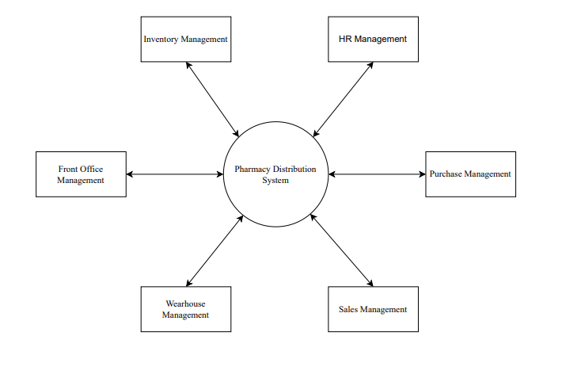

**3.1.1.2 1st Level DFD :**

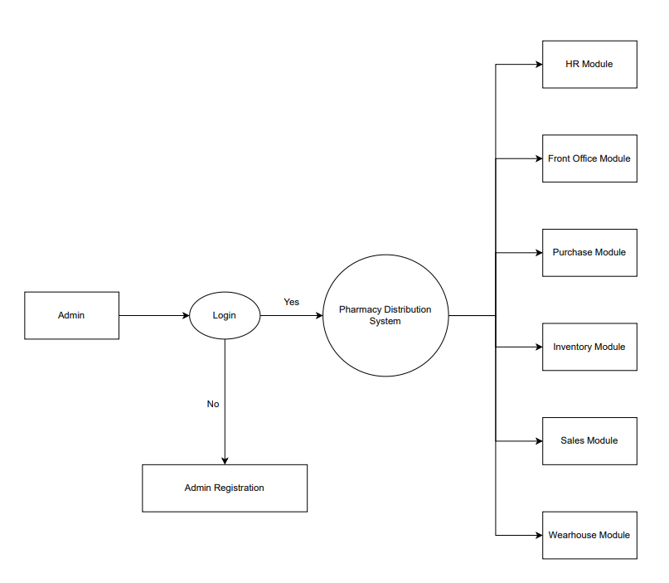

**3.1.1.3 2ed Level DFD :**

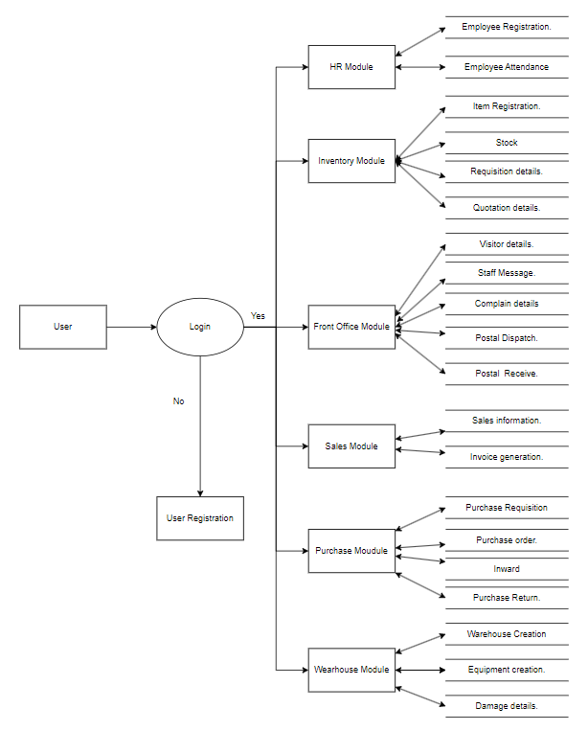

**3.1.2 ERD (Entity Relationship Diagram) :**

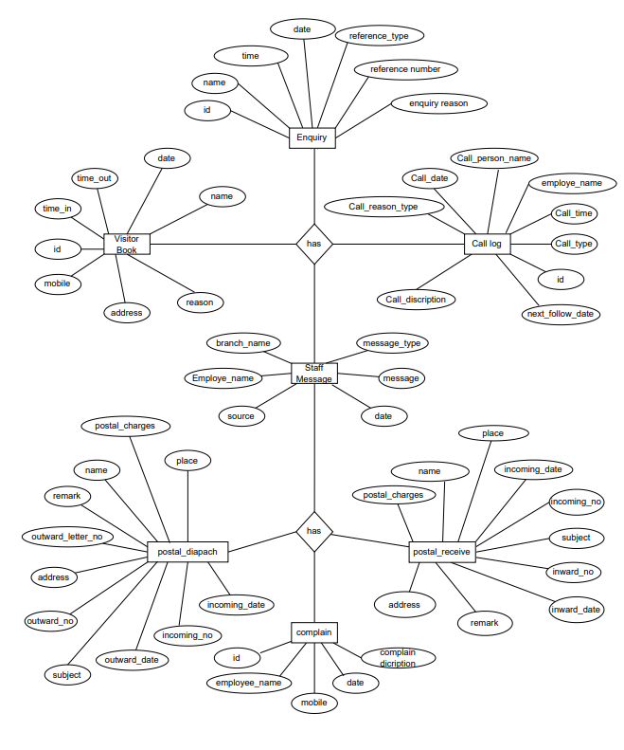

**3.1.3 UML (Unified Modeling Language) :**

**3.1.3.1. Use Case Diagram :**

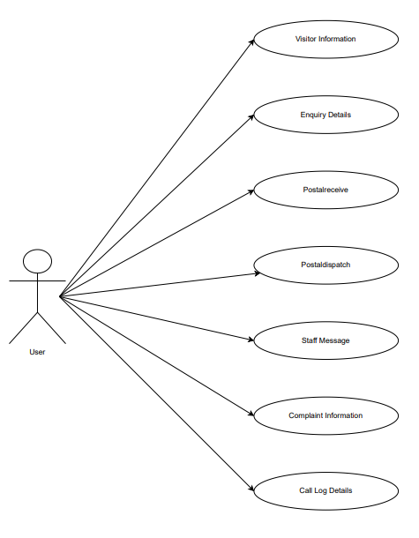

**3.1.3.2 Activity Diagram :**

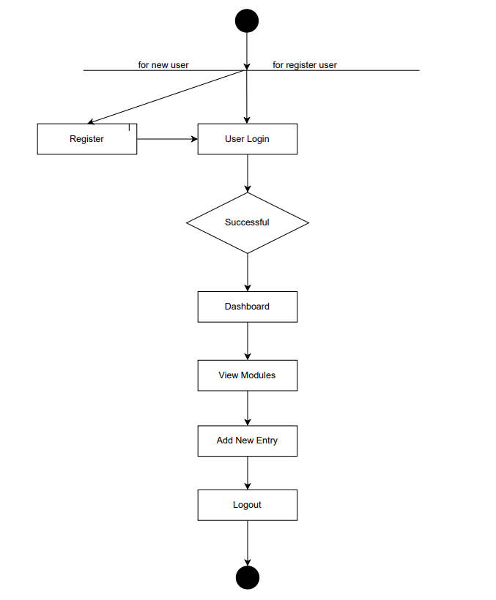

* + - 1. **Component Diagram:**

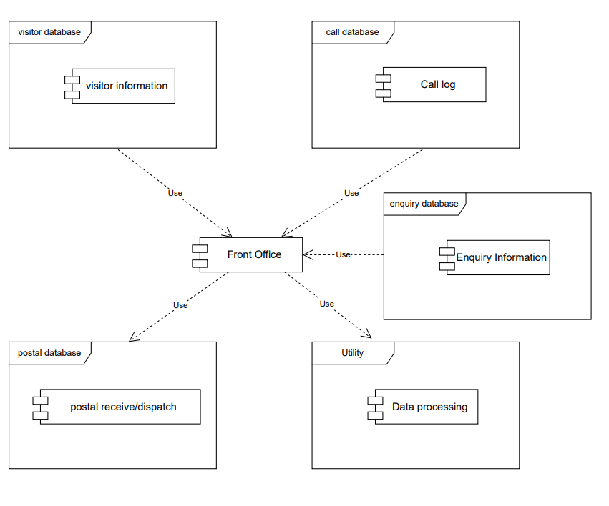

* + - 1. **Sequence Diagram:**

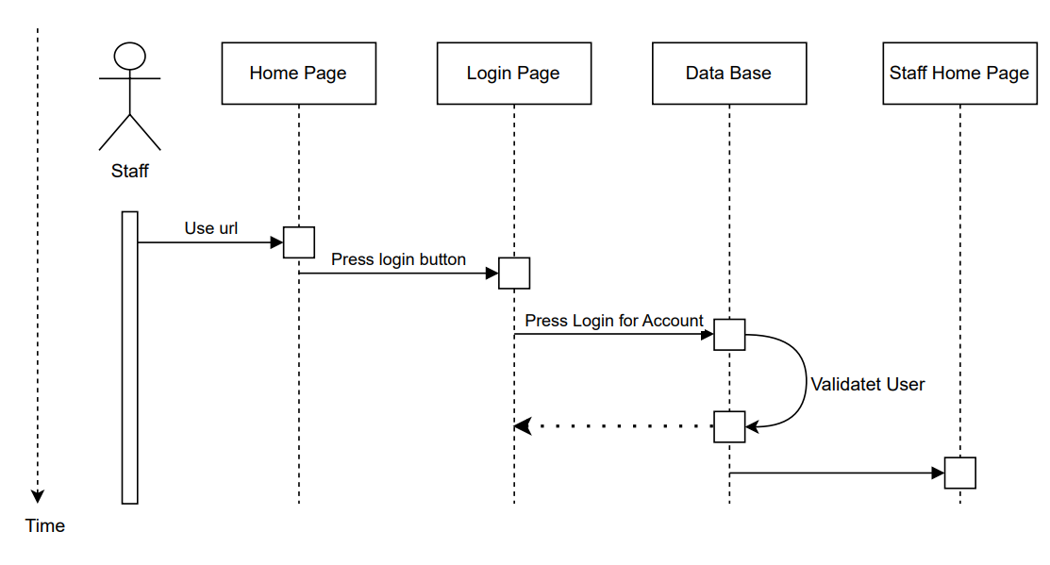

* + - 1. **Class Diagram:**

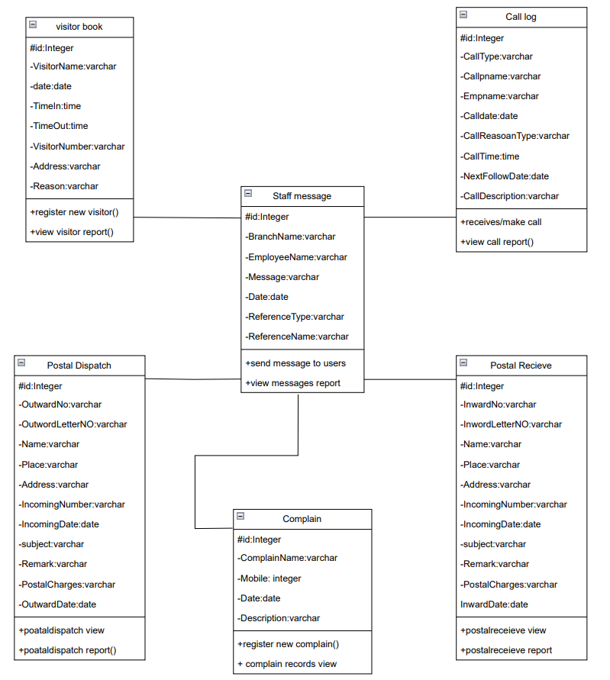

* + - 1. **State Diagram :**

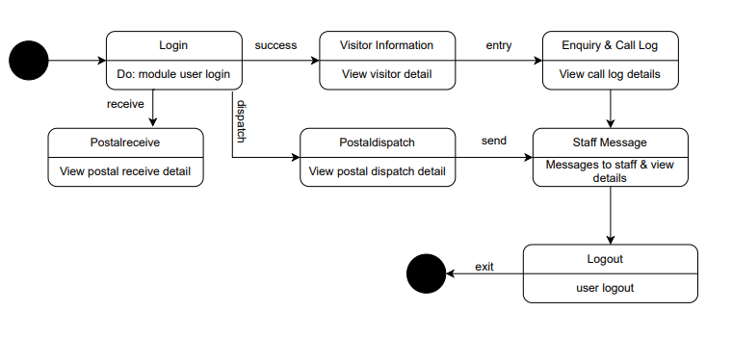

* + - 1. **Context Diagram :**

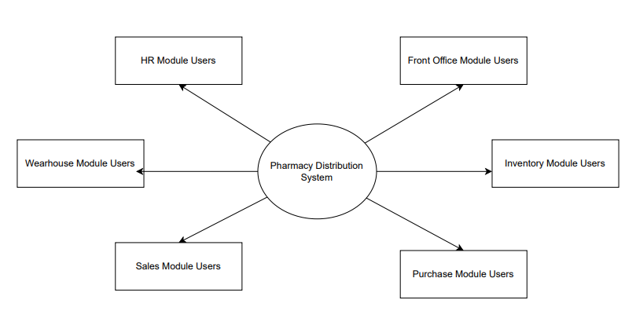

**3.1.3.8 Gantt Chart :**

27-05-2024 10-06-202417-06-2024 24-07-2024 01-07-2024 08-07-2024 26-07-2024



Project Kick Off

Submission Of Synopsis

Introduction To Database

Overview Of Frontend

SRS

Submission

System Diagrams

I/O Design

Database Connectivity

Reports

Project Complition

**3.1.3.9 Deployment Diagram :**

Network

Network

Network



**Work Station**



**Host Device**

**<<**

**>>**



**Pharmacy Distribution System**



<<

Software

>>



**Database Server**

**MySQL**



**Web Server**

**<<**

**APACHE**

**>>**



**Internet Service**

**Provider**

**>>**

**ISP**

**<<**



**Client**

**<<**

**Web Browser**

**>>**

# CHAPTER-4 SYSTEM DESIGN FOR

**PROJECT**

### **Database Design :**

### **1.Table : visitor book**

|  |  |  |  |
| --- | --- | --- | --- |
| **Name** | **Data Types** | **Size** | **Constraint** |
| Id | int | 10 | Primary Key |
| VisitorName | varchar | 20 | - |
| date | date | - | - |
| TimeIn | time | - | - |
| TimeOut | time | - | - |
| VisitorNumber | varchar | 10 | - |
| Address | varchar | 20 | - |
| Reasone | varchar | 50 | - |

**2.Table: enquiry**

|  |  |  |  |
| --- | --- | --- | --- |
| **Name** | **Data Type** | **Size** | **Constraint** |
| Id | int | 10 | Primary Key |
| EnquiryName | varchar | 20 | - |
| EnquiryTime | time | - | - |
| Date | date | - | - |
| ReferenceType | varchar | 50 | - |
| ReferenceName | varchar | 20 | - |
| ReferenceNo | varchar | 10 | - |
| EnquiryReason | varchar | 60 | - |

**3.Table: Call Log**

|  |  |  |  |
| --- | --- | --- | --- |
| **Name** | **Data Type** | **Size** | **Constraint** |
| id | int | 10 | Primary Key |
| CallType | varchar | 50 | - |
| Callpname | varchar | 50 | - |
| EmpName | varchar | 50 | - |
| Calldate | date | - | - |
| CallReasoanType | varchar | 10 | - |
| CallTime | time | - | - |
| NextFollowDate | date | - | - |
| CallDescription | varchar | 250 | - |
| Feedback | varchar | 50 | - |

**4.Table: postaldispatchdetails**

|  |  |  |  |
| --- | --- | --- | --- |
| **Name** | **DataType** | **Size** | **Constraint** |
| id | int | 10 | Primary Key |
| OutwordNo | varchar | 10 | - |
| OutwordLetterNo | varchar | 10 | - |
| OutwordDate | date | - | - |
| Name | varchar | 20 | - |
| Place | varchar | 20 | - |
| Address | varchar | 50 | - |
| IncomingNumber | varchar | 50 | - |
| IncomingDate | date | - | - |
| subject | varchar | 50 | - |
| Remark | varchar | 50 | - |
| PostalCharge | varchar | 100 | - |

**5.Table: postalreceive**

|  |  |  |  |
| --- | --- | --- | --- |
| **Name** | **Data Type** | **Size** | **Constraint** |
| id | int | 10 | Primary Key |
| InwordNo | varchar | 10 | - |
| InwordLetterNo | varchar | 10 | - |
| InwordDate | date | - | - |
| Name | varchar | 20 | - |
| Place | varchar | 20 | - |
| Address | varchar | 50 | - |
| InNoReference | varchar | 50 | - |
| InDateReference | date | - | - |
| SubjectOfCorres | varchar | 50 | - |
| Remark | varchar | 50 | - |
| PostalCharge | varchar | 100 | - |

**6.Table: Staff**

|  |  |  |  |
| --- | --- | --- | --- |
| **Name** | **DataType** | **Size** | **Constraint** |
| id | int | 10 | Primary Key |
| BranchName | varchar | 50 | - |
| EmployeeName | varchar | 10 | - |
| Message | varchar | 100 | - |
| Date | date | - | - |
| ReferenceType | varchar | 50 |  |
| ReferenceName | varchar | 20 |  |

**7.Table: Complain**

|  |  |  |  |
| --- | --- | --- | --- |
| **Name** | **Data Type** | **Size** | **Constraint** |
| id | int | 10 | Primary Key |
| ComplainName | varchar | 50 | - |
| Mobile | varchar | 10 | - |
| Date | date | - | - |
| Description | varchar | 100 | - |

* 1. **Input Design & its samples :**

**Enquiry Form :-**

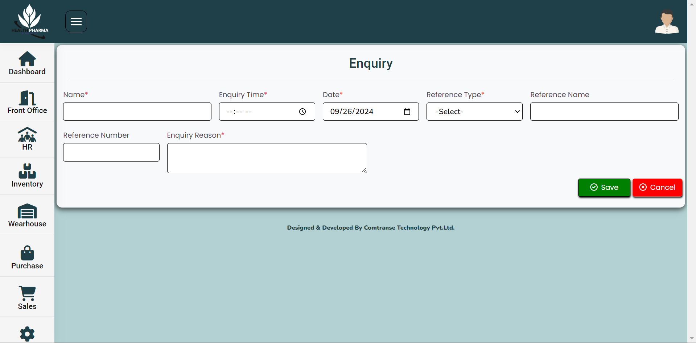

**Visitor Book Form :-**

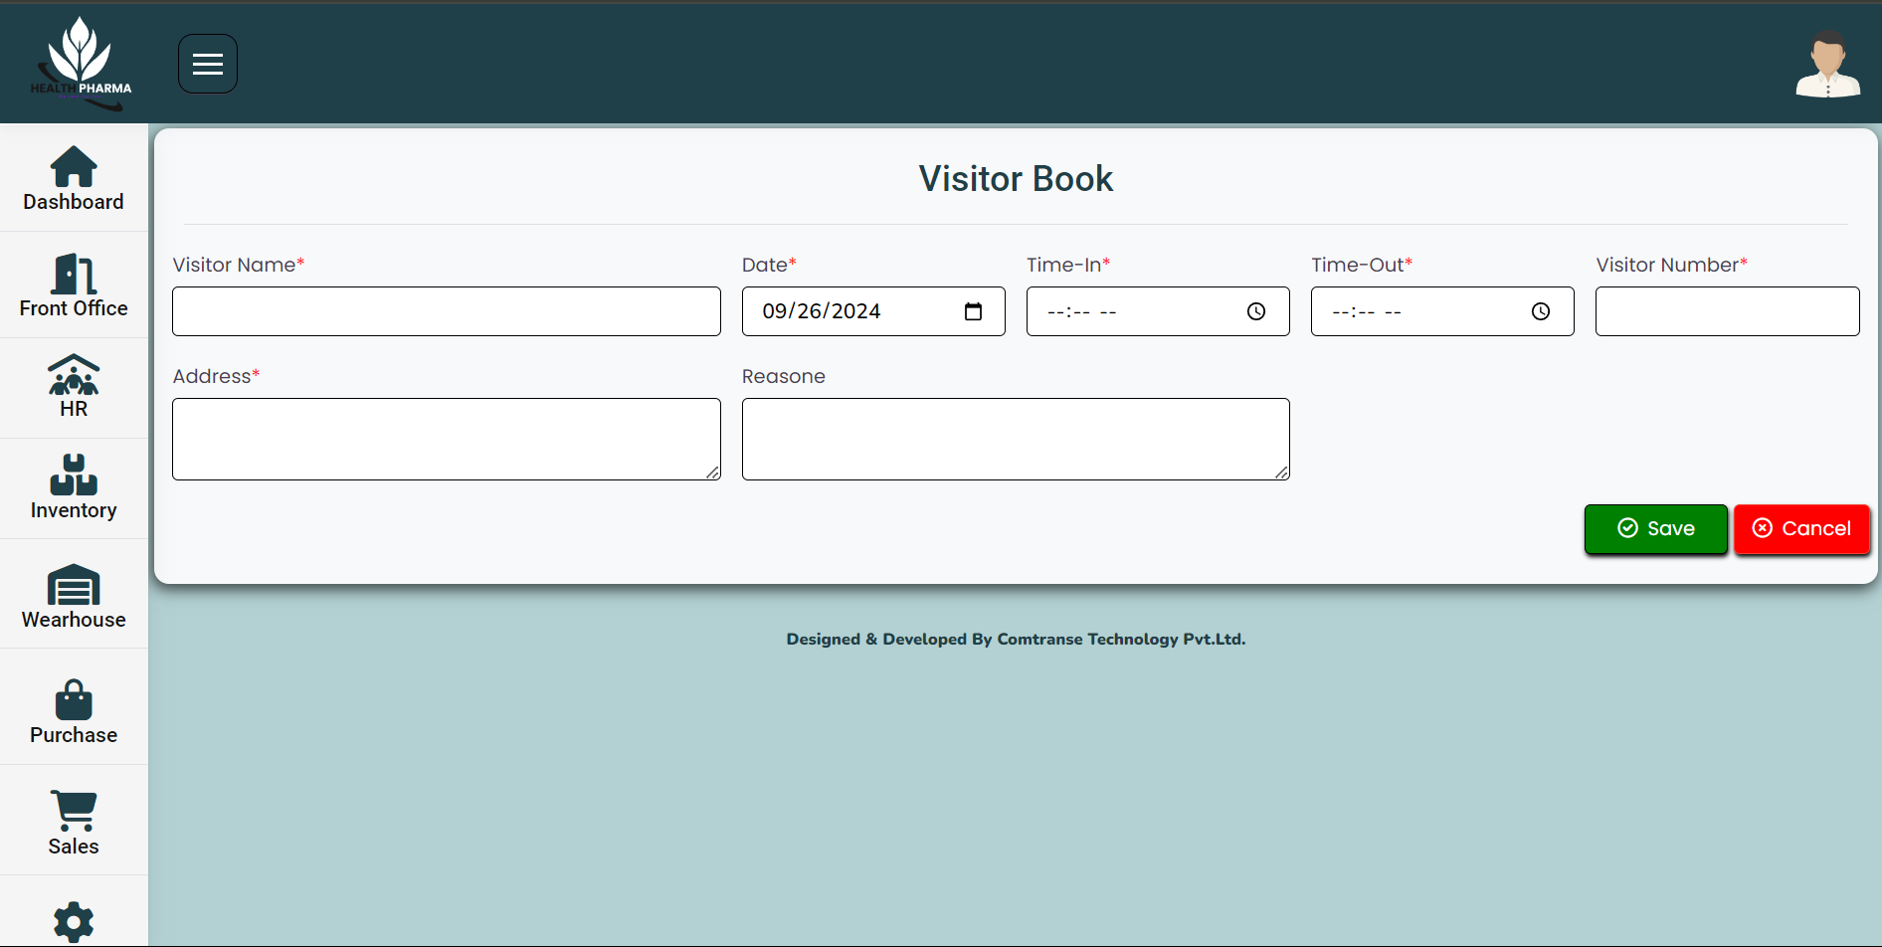

**Call Log Form :-**

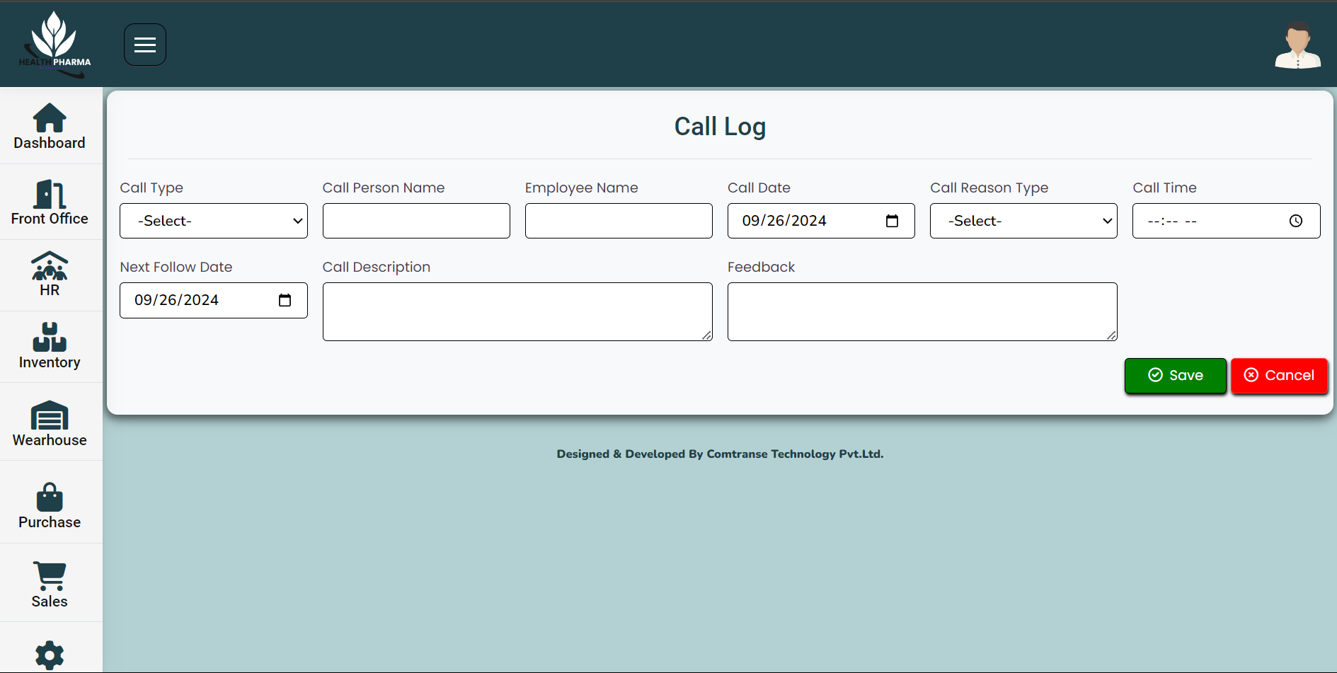

**Postal Recieve Form :-**

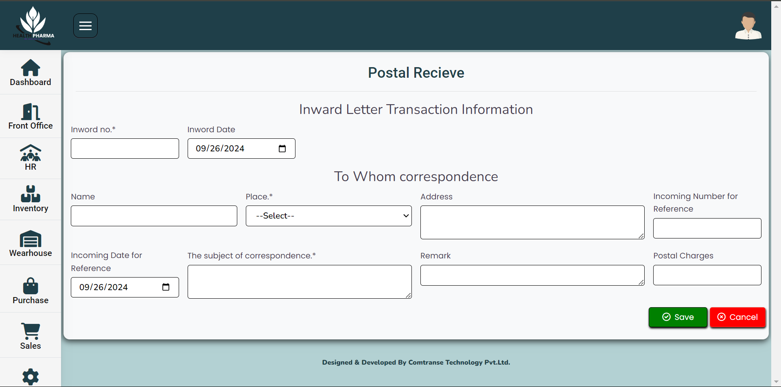

**Postal Dispatch Form :-**

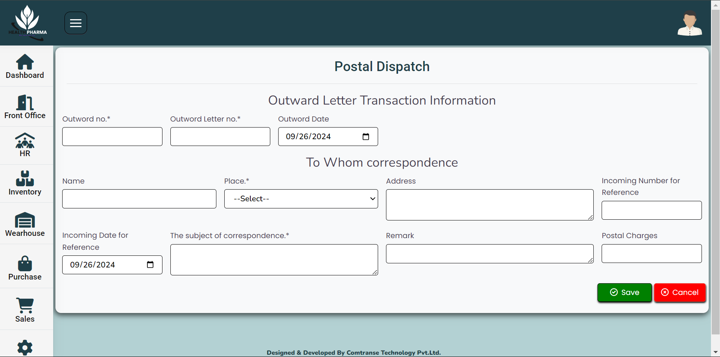

**Staff Message Form :-**

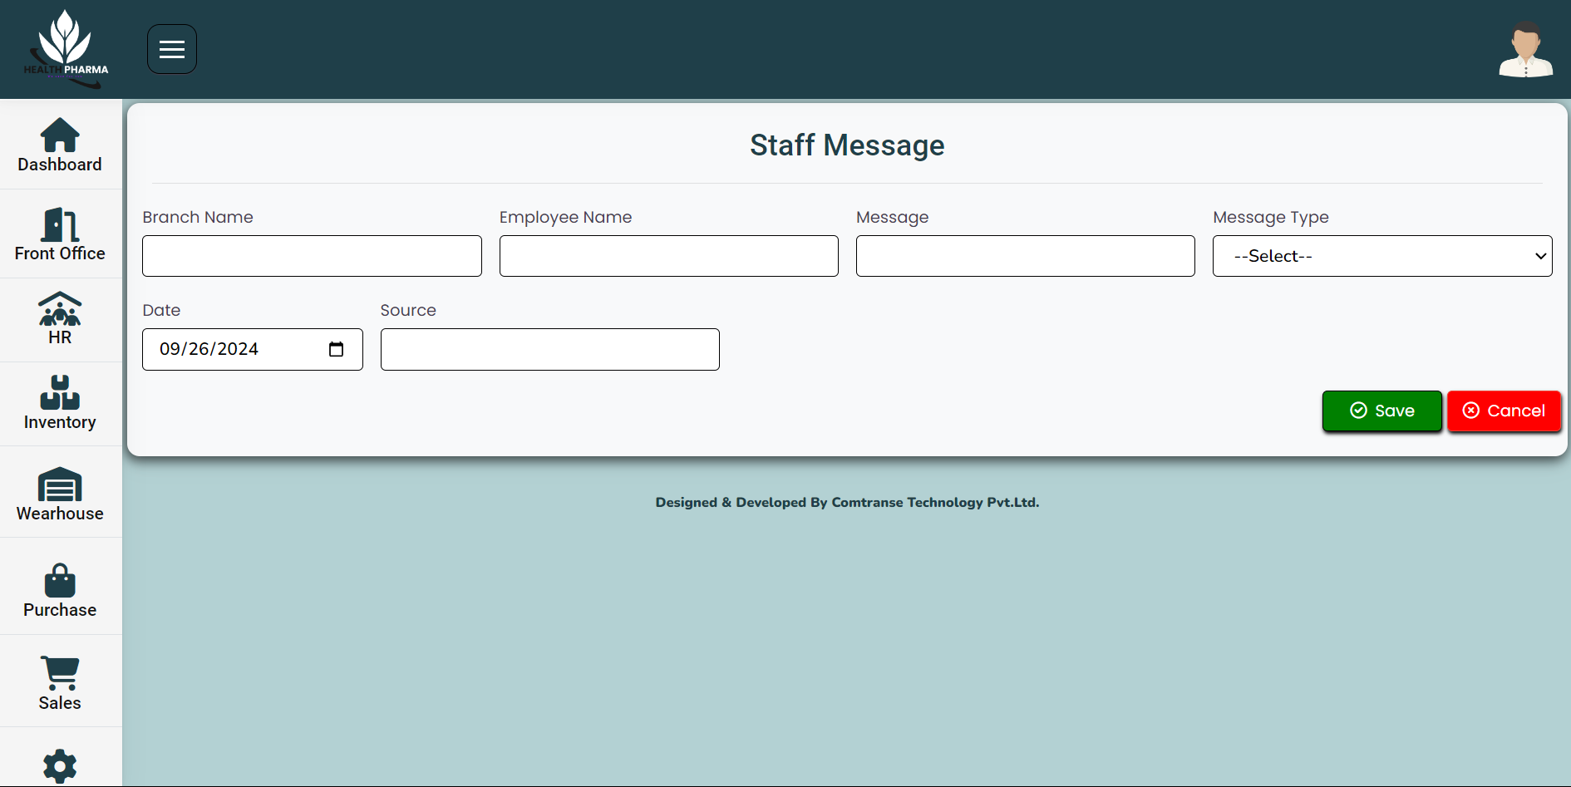

**Complain Form :-**

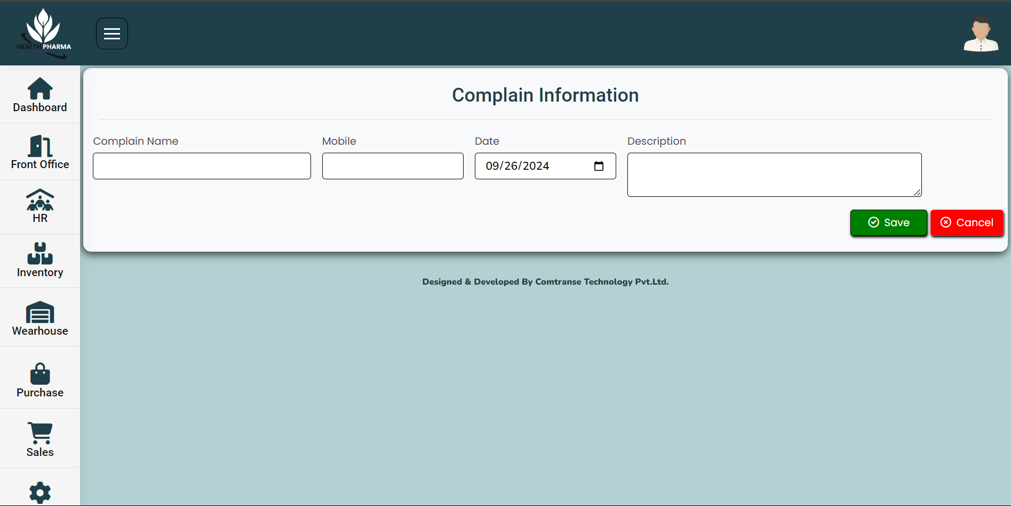

**Employee List :-**

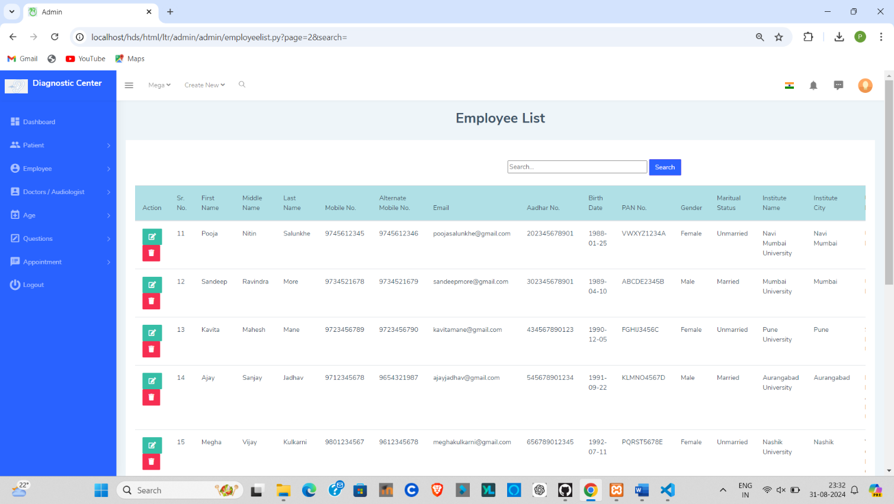

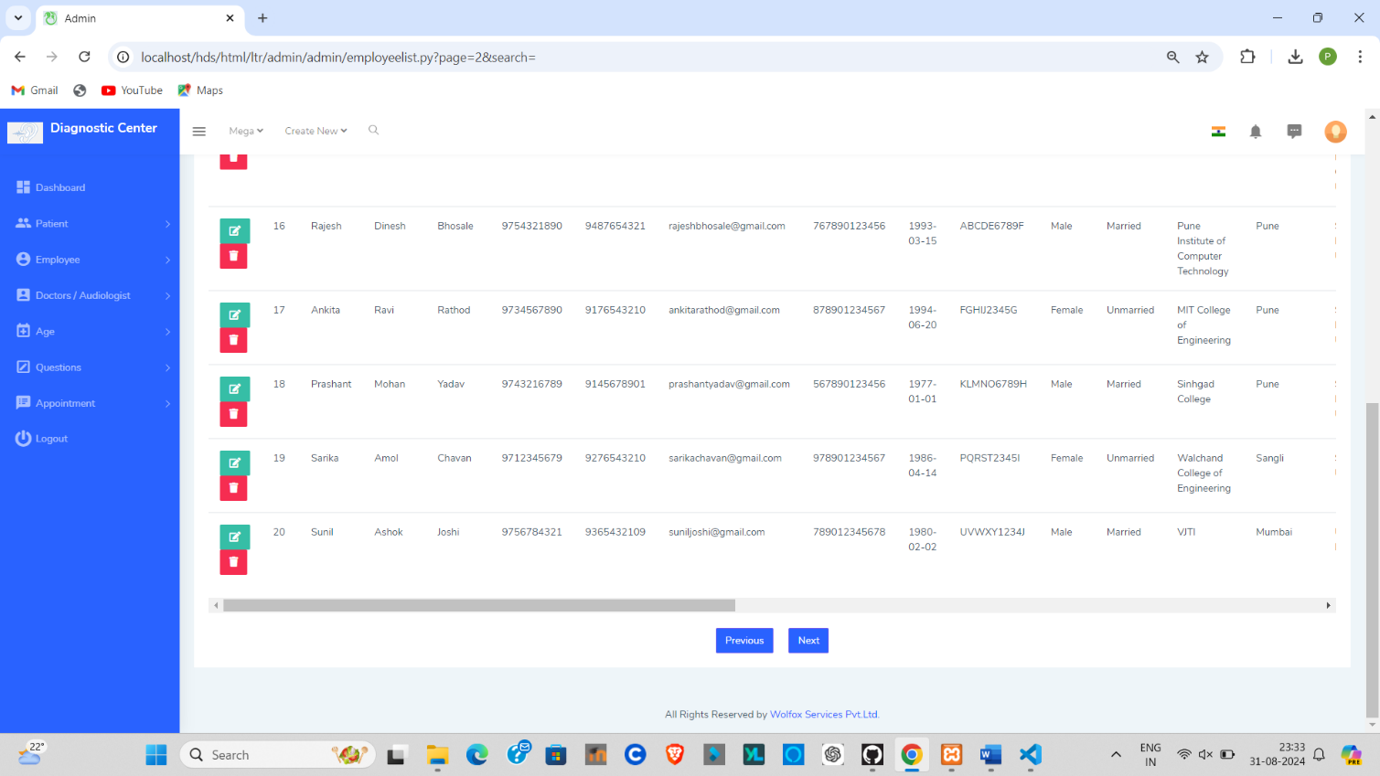

**Patient Registraion :-**

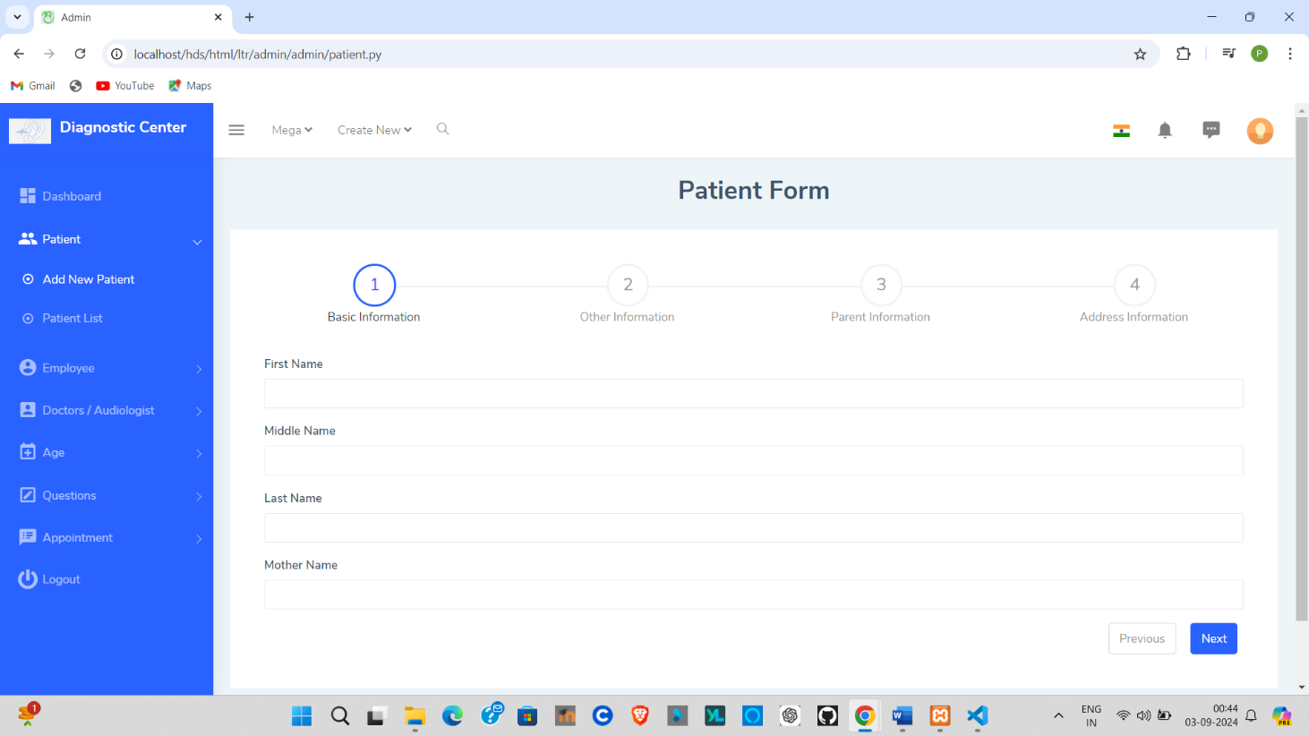

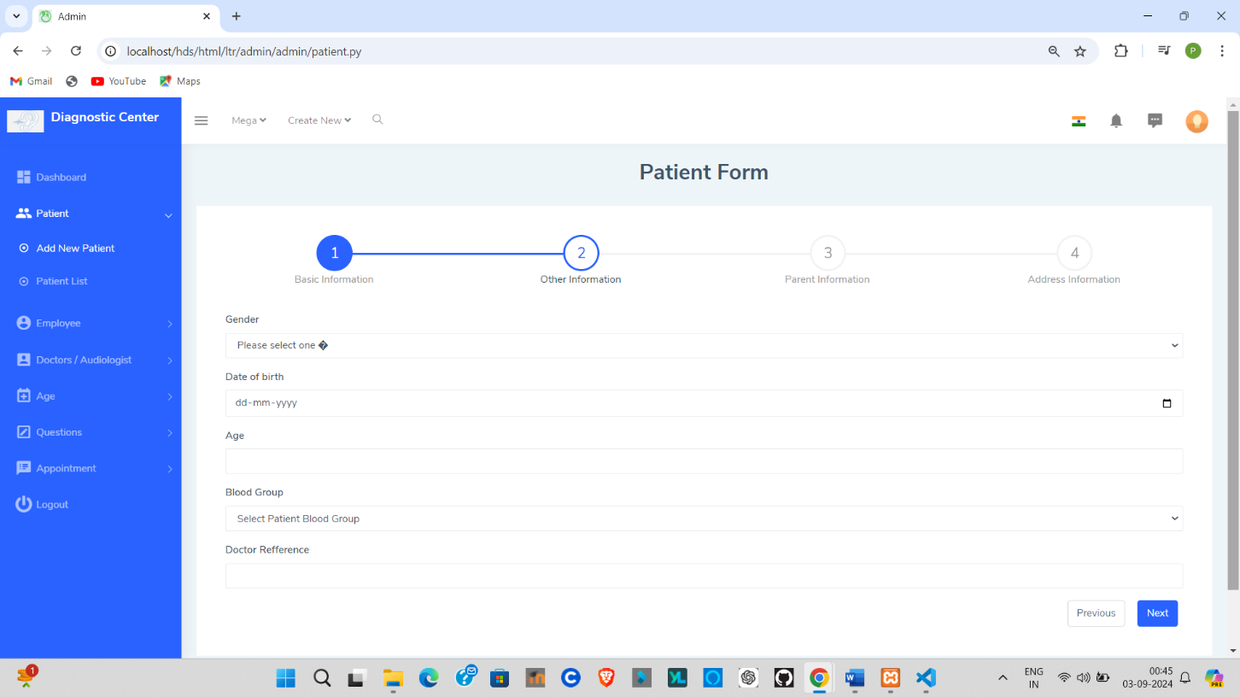

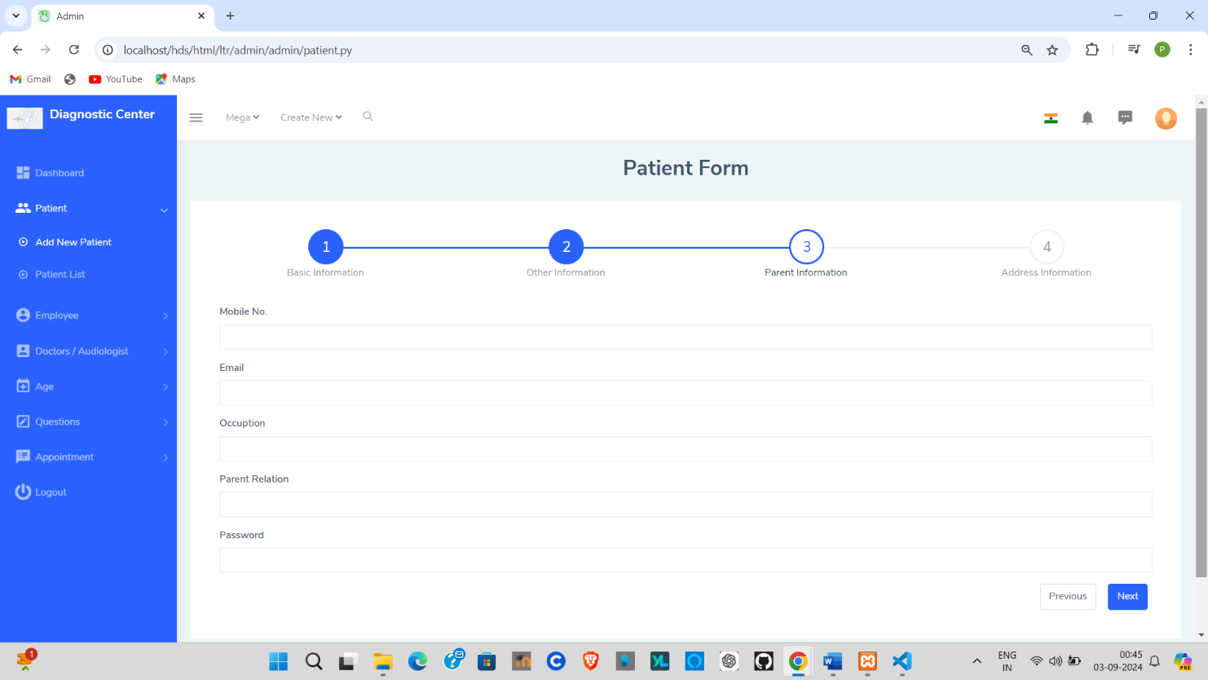

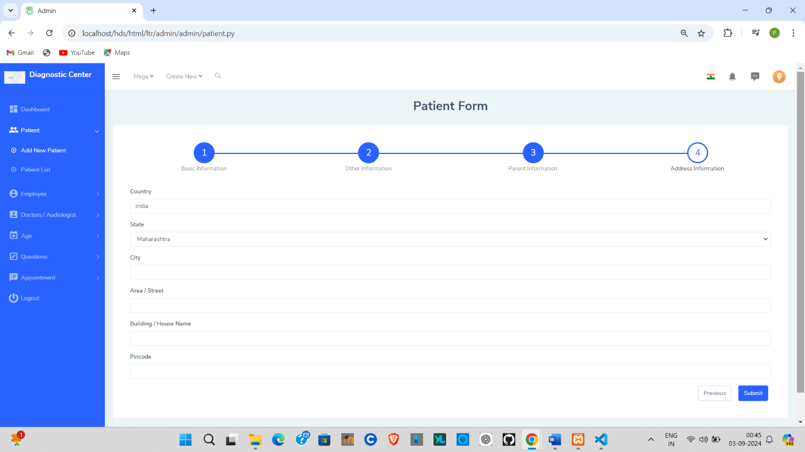

**Patient List:-**

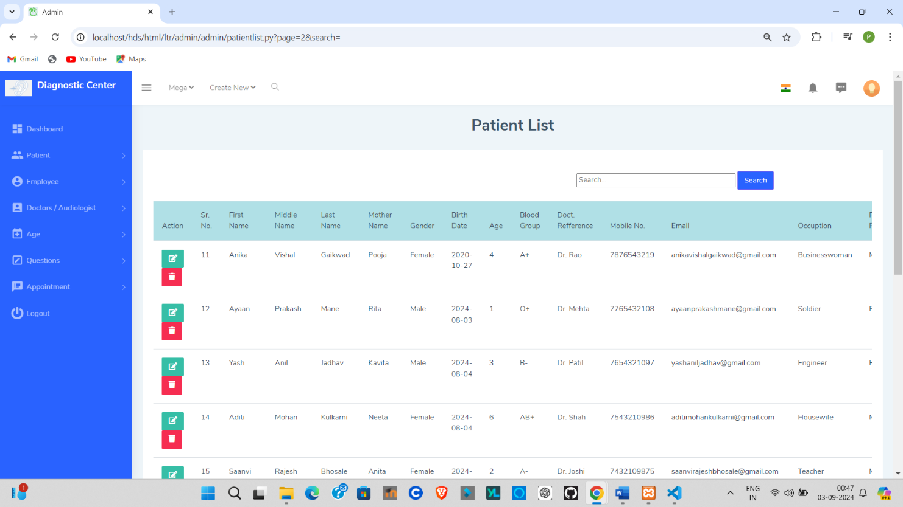

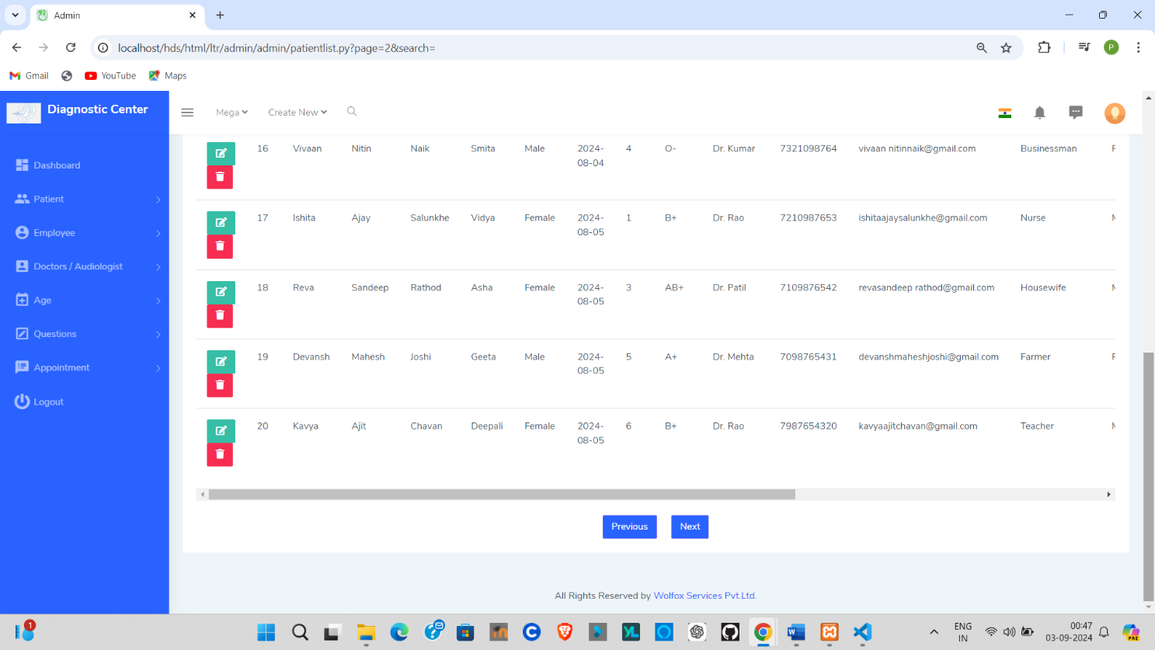

* 1. **Output Design (on screen) :-**

**Employee Registraion :-**

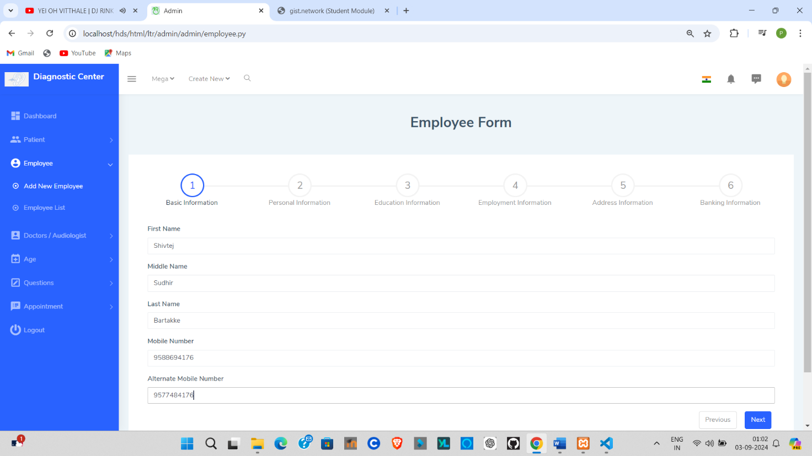

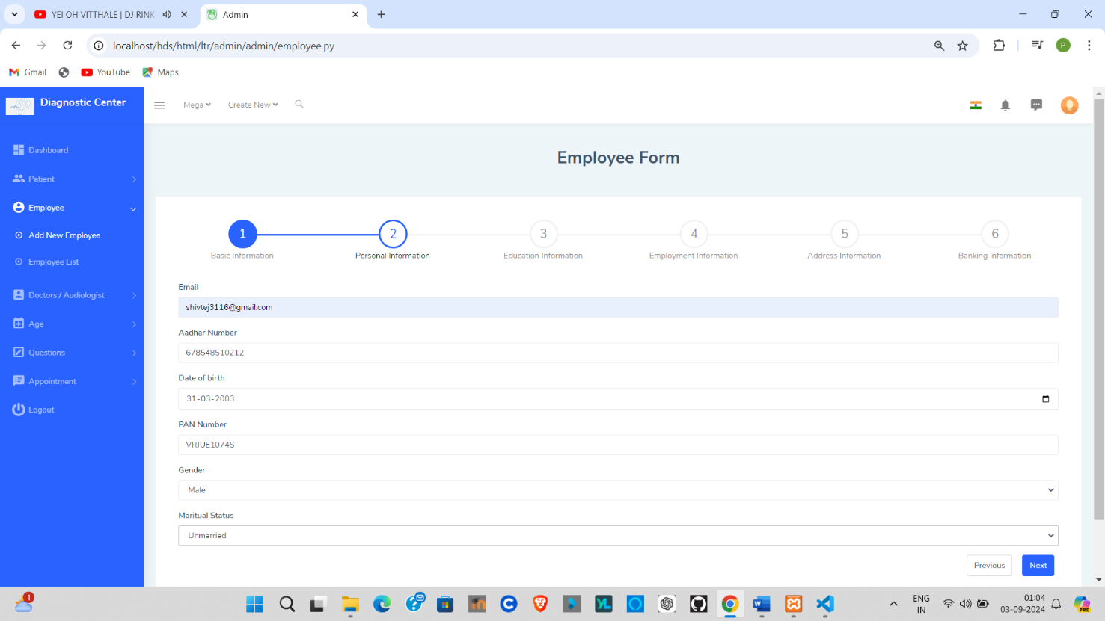

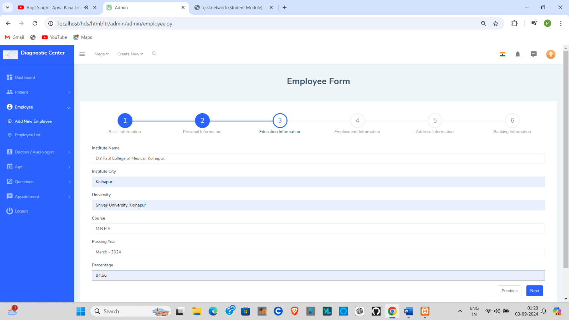

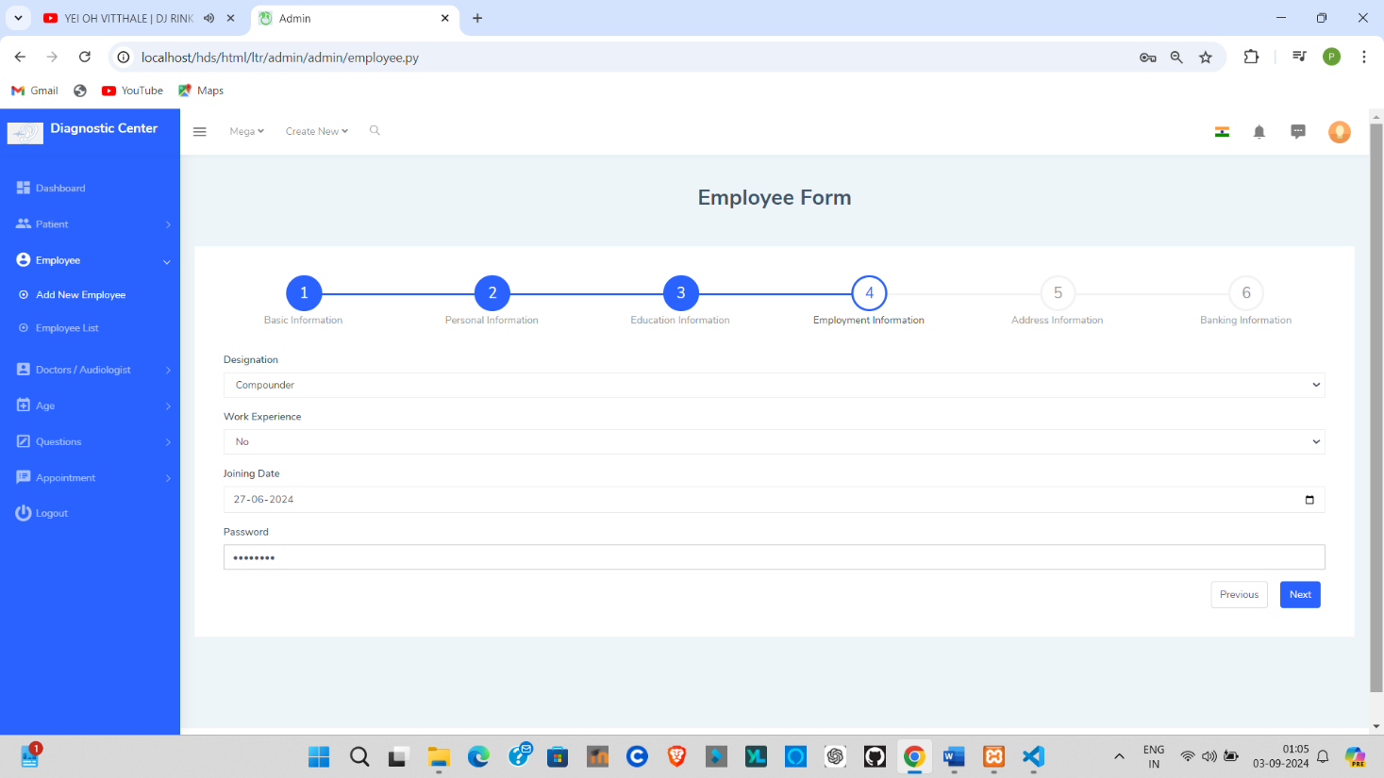

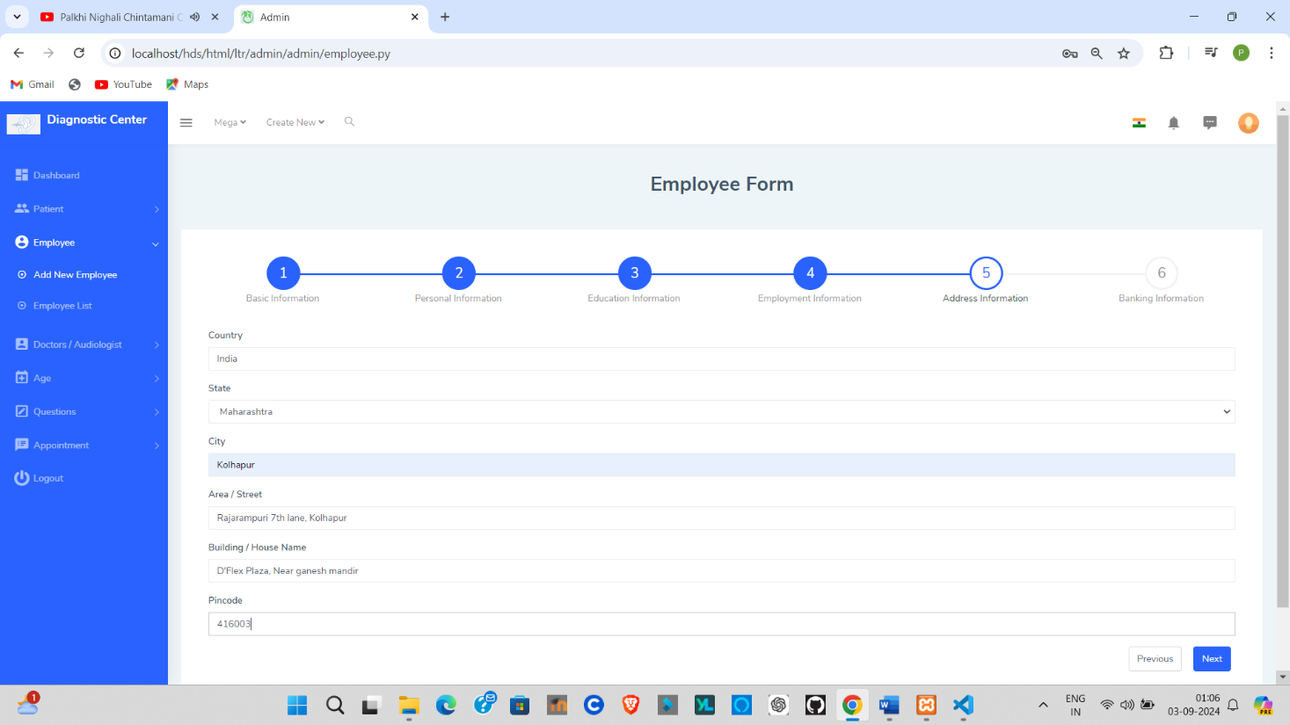

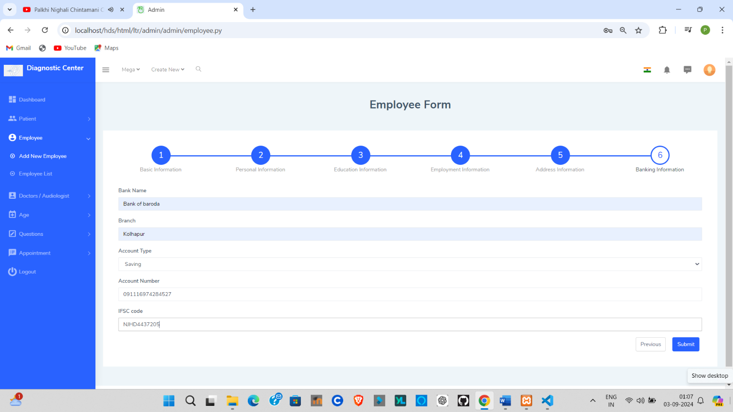

**Employee Registraion Successful :-**

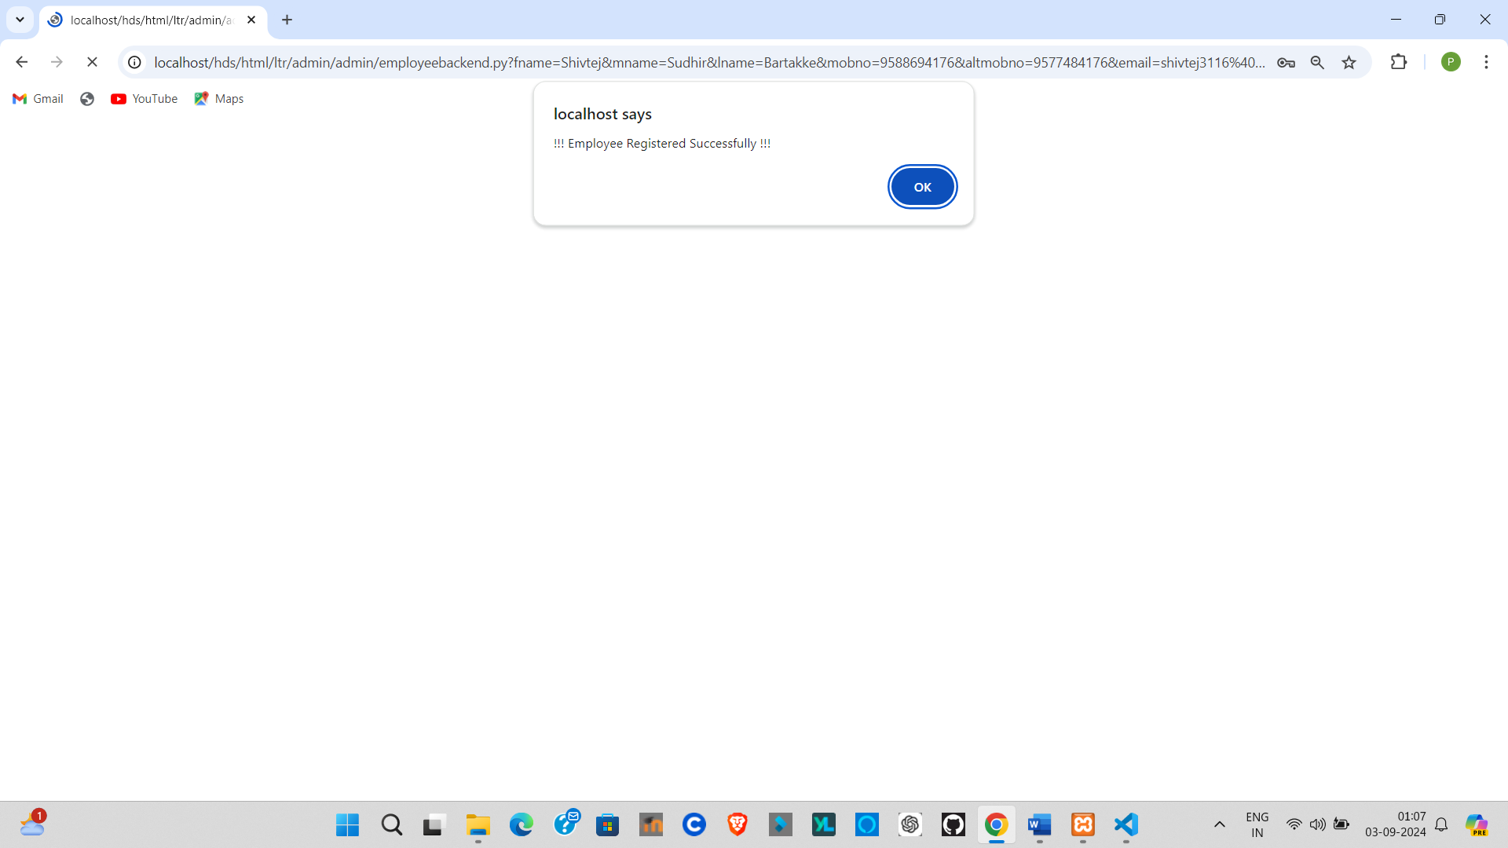

**Patient Registraion :-**

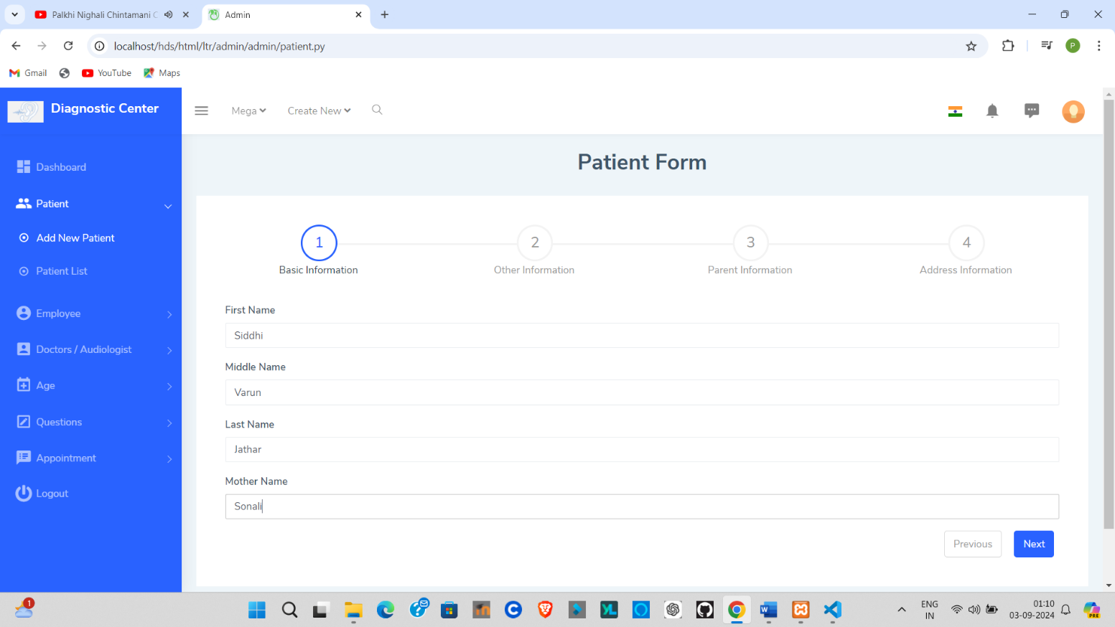

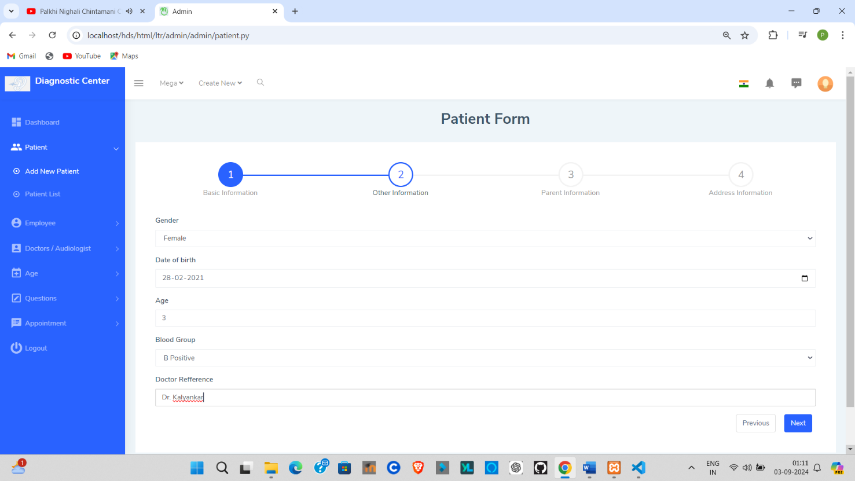

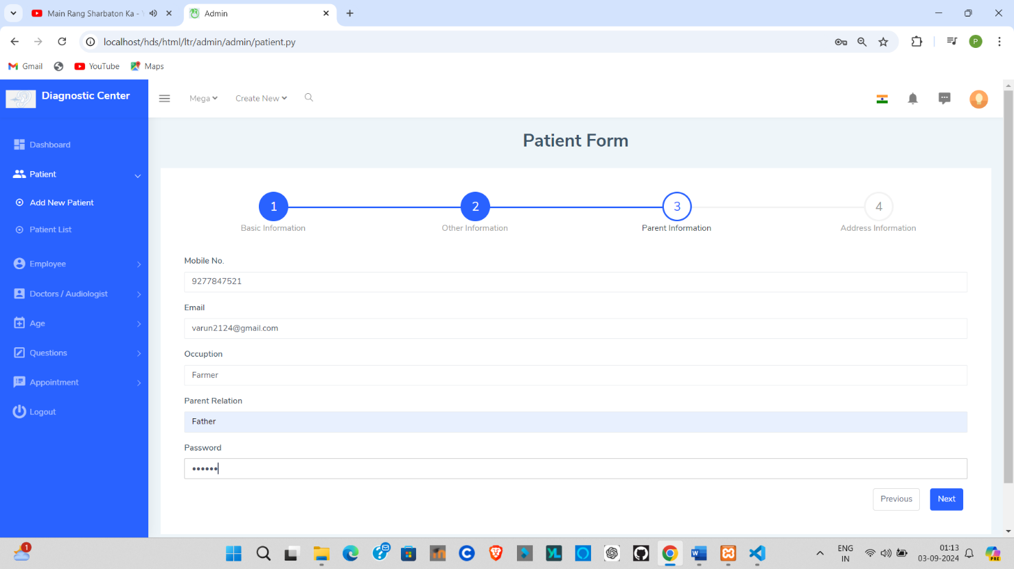

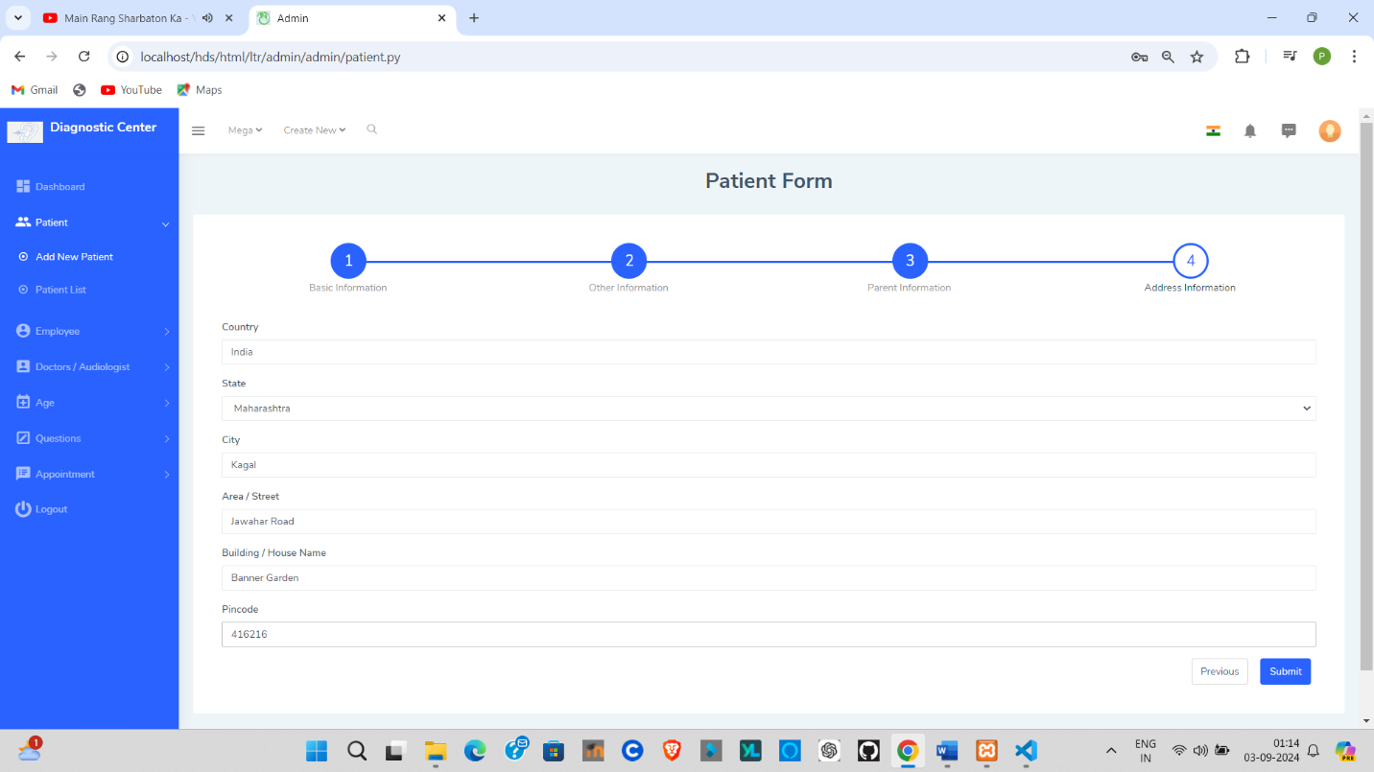

**Patient Registraion Successful :-**

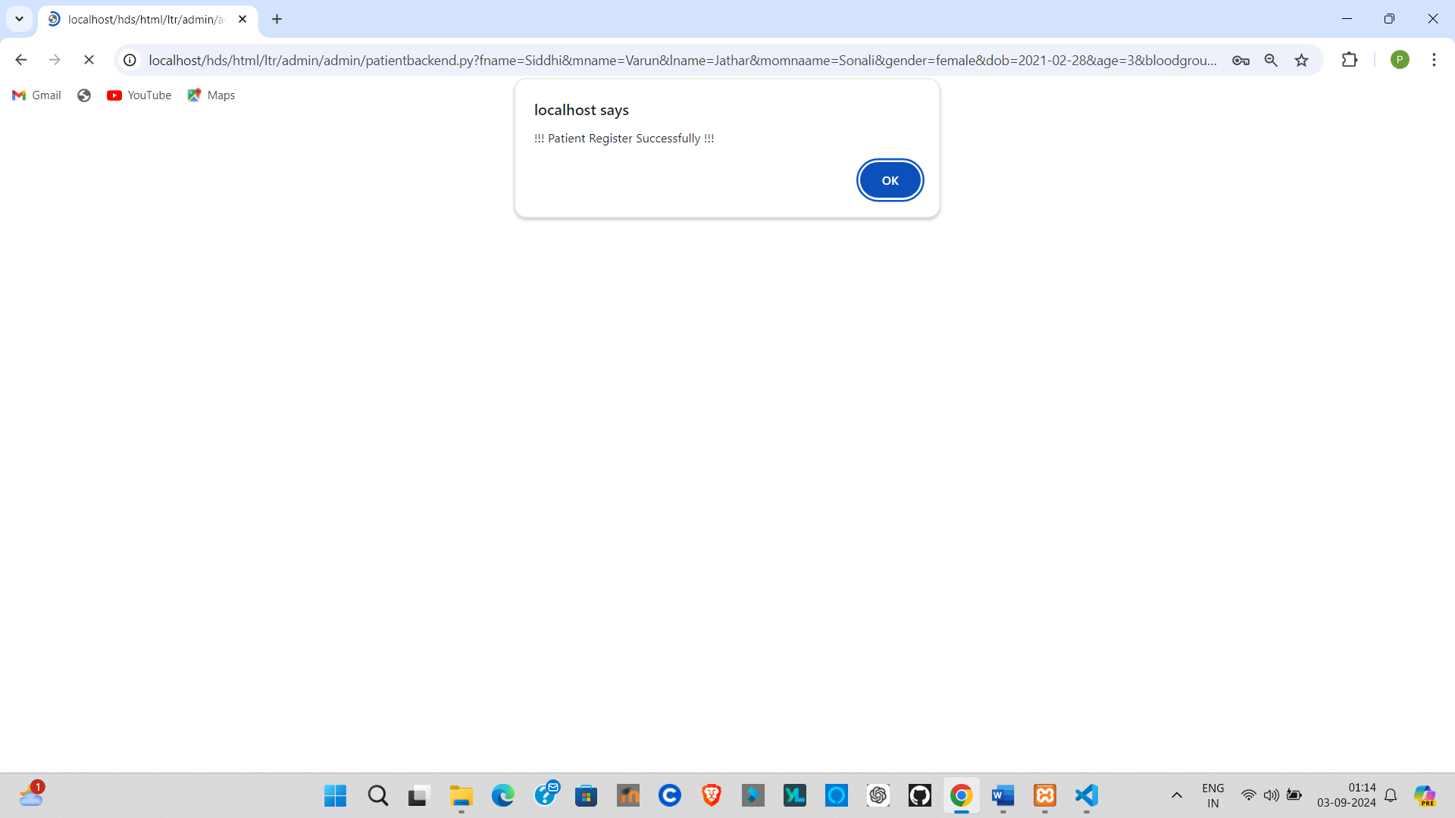

# CHAPTER-5

**IMPLIMENTATION OF**

# PROJECT

**5.1 System Requirement :**

Operating Environment – Hardware and Software

For this project various technologies are used as follows:

**Operating System**

• Windows 10

• 64 -bit operating system

• 8 GB RAM or More

**Client-Side Scripting**

• HTML

• CSS

• JavaScript

• Bootstrap

**Server-Side Scripting**

• PHP

**Database Tool**

• MySQL

**Web Server**

• Apache

### **5.2 Installation Process :**

Computer programs can be executed by simply copying them into a folder stored on a computer and executing them. Other programs are supplied in a form unsuitable for immediate execution, and therefore need an installation procedure Once installed, the program can be executed again and again without the need to reinstall before each execution.

**Operations performed during software reinstallations include:**

* Making sure that necessary system requirements are met.
* Checking for existing versions of the software.
* Creating or updating program files and folders.
* Adding configuration data such as configuration file window registry entry for environment variables.
* Making the software accessible to the user. For instance, by creating links, short Custer bookmarks.
* Configuring components the that run automatically, such as demonstrator Window services.
* Performing product activation.
* Updating the software versions.

These operations may require some charges or be free of charge. In case of payment, installation costs mean the cost connected and relevant to or incurred as a result of installing the drivers

or the equipment in the customers’ premises.

### **PHP :**

PHP is a general-purpose scripting language that is particularly well-suited for a wide range of development tasks, including web development, server-side scripting, automation, and more. PHP code is typically interpreted by a web server with a PHP runtime module, which allows it to be used across different platforms and operating systems.

PHP can be embedded in various web pages, and its code is often integrated with other languages like HTML, CSS, and JavaScript to create dynamic and complex web applications. It is commonly used in server-side development for websites, content management systems, and e-commerce platforms.

PHP is highly versatile and can be deployed across numerous environments, including web servers, cloud services, and command-line interfaces. It is compatible with various relational database management systems (RDBMS), such as MySQL, PostgreSQL, and SQLite.

PHP is freely available, and its development is managed by The PHP Group. The complete source code is available, enabling users to build, customize, and extend the language to meet their specific needs.

### **Apache :**

The Apache HTTP Server is a web server software notable for playing a key role in the initial growth of the World Wide Web In 2009 it became the first web server software to surpass the 100 million web site milestone Apache is developed and maintained by an open community of developers under the auspices of the Apache Software Foundation. Since April 1996 Apache has been the most popular HTTP server software in use As of November 2010 Apache served over 59 36% of all websites and over 66 56% of the first one million busiest websites

### **XAMPP :**

XAMPP is a small and light Apache distribution containing the most common web development technologies in a single package Its contents, small size, and portability make it the ideal tool for students developing and testing applications in PHP and MySQL XAMPP is available as a free download in two specific packages full and Me While the full package download provides a wide array of development tools XAMPP Lite contains the necessary technologies that meet the Ontary Skills Competition standards. The light version is a small package containing Apache Http Server, PHP, MySQL, phpMyAdmin, OpenSSL and SQLite.

### **5.2.4 Obtaining and Installing XAMPP :**

As previously mentioned,. XAMPP is a free package available for download and use for various web development tasks All XAMPP packages and add-ons are distributed through the Apache Friends website at the address http://www.apache friends.org/ Once on the website, navigate and find the Windows version of XAMPP and download the self- extracting ZIP archive After downloading the archive, run and extract is contents into the root path of a hard disk or USB drive For example, the extract path for a local Windows installation would simply be C If extracted properly we will notice a new xampp directory in the root of your installation disk In order to test that everything has been installed correctly. first start the Apache HTTP Server by navigating to the xampp directory and clicking on the Apache start.bat batch file.

Next we will test if the server is running correctly by opening an internet browser and typing <http://localhost/dashboard/> the address bar If configured correctly, we will be presented with a screen similar to that of the one below.

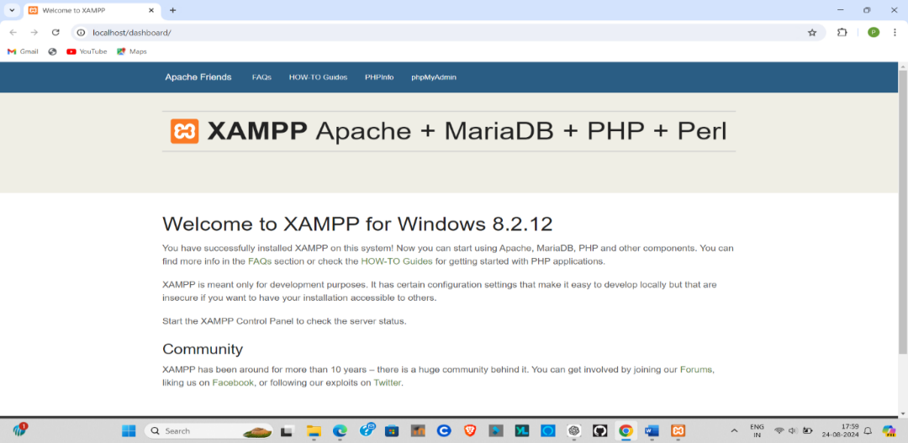

In order to stop all Apache processes we do not close the running terminal application, but instead run another batch file in the xampp lite directory called apache_stop.bat

Creating a Database and Inserting Data Now that we have run and tested Apache and PHP, the next step is running MySQL and creating a database and table which will hold information to be used by our website. In order to start MySQL, navigate to the xampp directory and run the mysql start.bat batch file. The XAMPP package contains an application called phpMyAdmin which allows developers to administer and maintain MySQL databases. We will be using phpMyAdmin to create a database and table, and enter test data. Before testing phpMyAdmin, make sure that both Apache and MySQL are running by opening their respective batch files apache_start.bat and mysql start.bat Aking with Apache and MySQL running in the background, we type <http://localhost/phpMyAdmin/>into our web browser. If successful we will be presented with a phpMyAdmin start page similar to the one shown below.

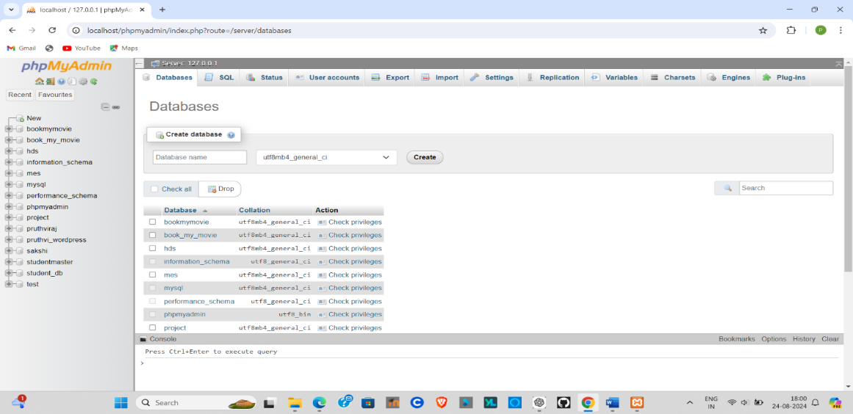

The first step with phpMyAdmin running is creating a new database We create a new database by directly executing SQL statements as shown below. The successful execution of the sql query creates a database ‘hds’ with tables in it.

**5.3 User Guideline :**

The “Pharmacy Distribution System” is designed to be user-friendly and intuitive for both users and Admin of the system. Below are the guidelines for using the system, organized to ensure that all users can make the most of its features:

**1. Login and Registration :**

**Admin :**

1. Admin Should have to login to this system by providing login username and password.
2. Admin can create roles, define role permissions, create users and assigns roles to user.
   * + - Through user access assign ,can give specific access control to user.
       - Admin can create user. It will create a user with password as user code.
       - Admin has full Administration Control.

**User (Sub-Admin and Staff) :**

Users should have to login to login to this by providing login username and password.

* User will get the Menus as per the roles assigned by Admin.
* After getting the forms the user can start further interaction with the system.
* User can view all the total assigned tasks and completed tasks like wise.

**2. Dashboard Navigation :**

**Users :**

After logging in, the dashboard provides a quick overview of scheduled appointments, pending assessments, and past results. Use the navigation menu to easily access specific sections.

**Admin Users :**

Admin users can navigate through different master pages (e.g., Patient Master, Employee Master) using the main dashboard. Each section allows for easy management of data via tables, forms, and search options.

**3. Managing Data :**

**Adding/Updating Records:**

Admin users should use the appropriate master pages or forms to input or update information. Forms are provided for entering details.Be sure to fill in all required fields before submitting the form.

**Viewing Records :**

Data Tables are provided for displaying all records. Use the built-in search, sort, and filter functions to quickly find the information you need.

**4. Viewing and Downloading Reports :**

**Users(Staff or Sub-Admin) :**

After completing an assessment, the results or data will be available for review on the dashboard. You can also download or print the report for personal records or share it with auditing professionals or any other.

**Admin Users :**

Admins can generate reports based on results. These reports are accessible from the admin dashboard and can be shared with auditing professionals or any other if they needed.

**7. Security and Password Management :**

**Password Recovery :**

In case you forget your password, use the "Forgot Password" feature on the login page. You will be prompted to enter your registered email, and instructions for resetting your password will be sent to you.

**Data Security :**

The system is designed with security in mind. Always ensure that you log out after each session, especially when using a shared computer, to protect your personal and patient data.

By following these guidelines, users will be able to navigate and utilize the Pharmacy Distribution System effectively, ensuring smooth operations and user friendly experience.

# CHAPTER-6 REPORTS OF

**PROJECT**

**6.1 Gender-wise Patient Report :**

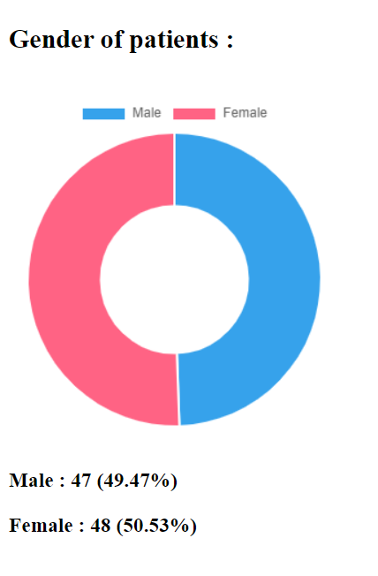

**6.2 Age-wise Patient Report :**

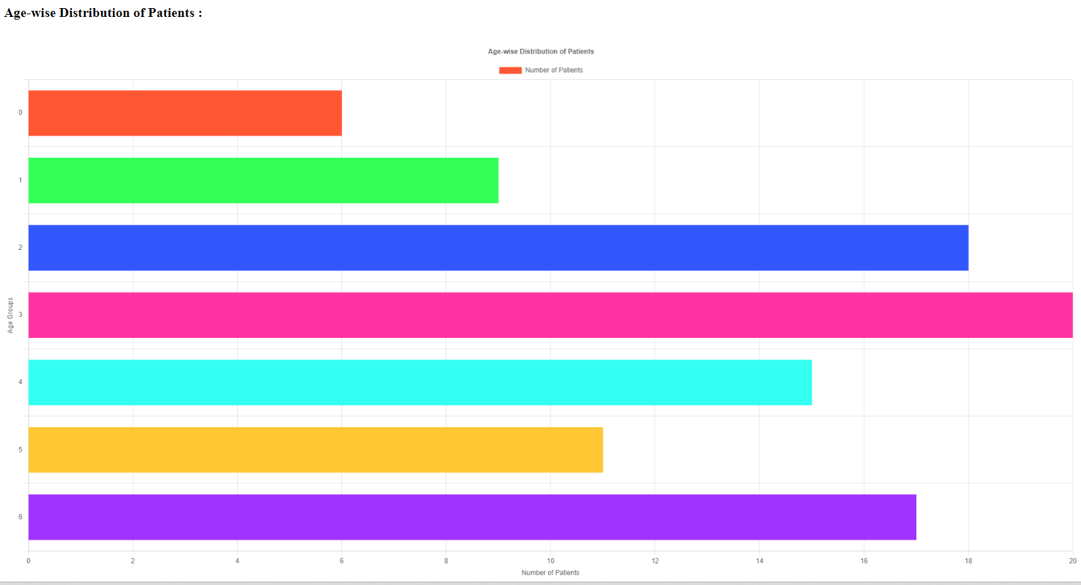

**6.3 Employee Report :**

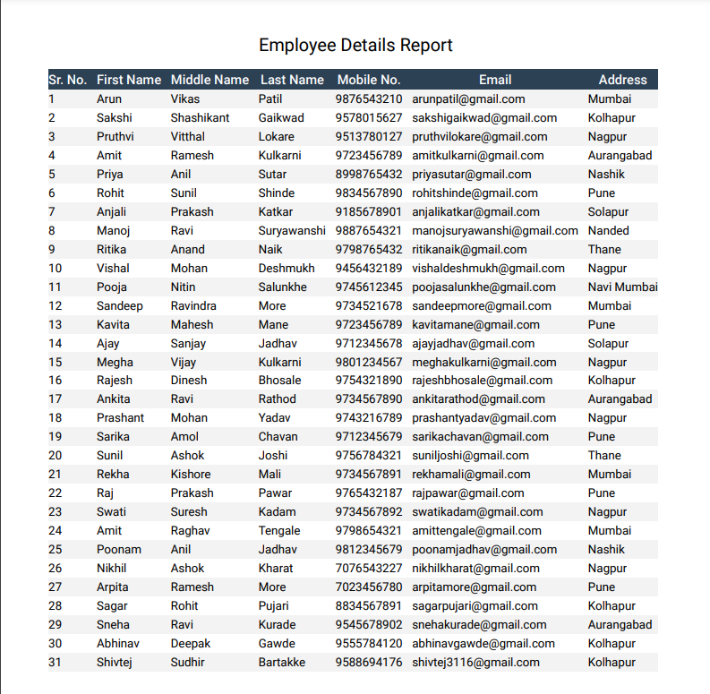

**6.4 Employment Report :**

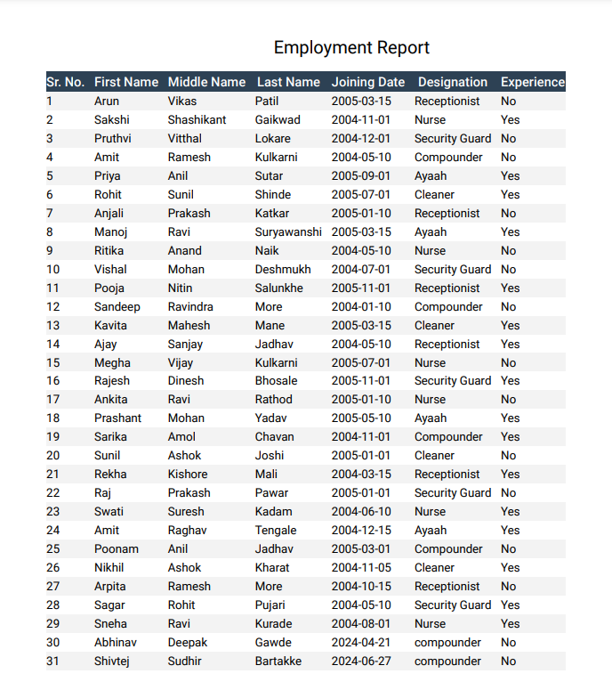

**6.5 Employee Datewise Joining Report :**

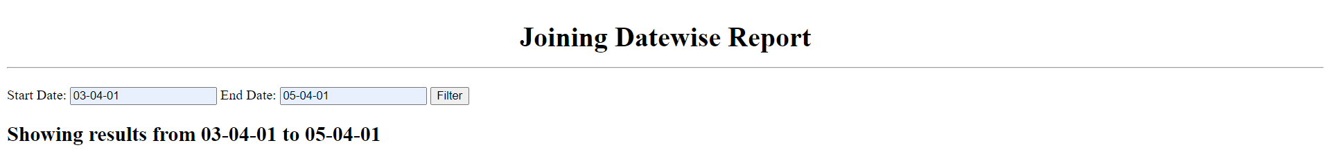

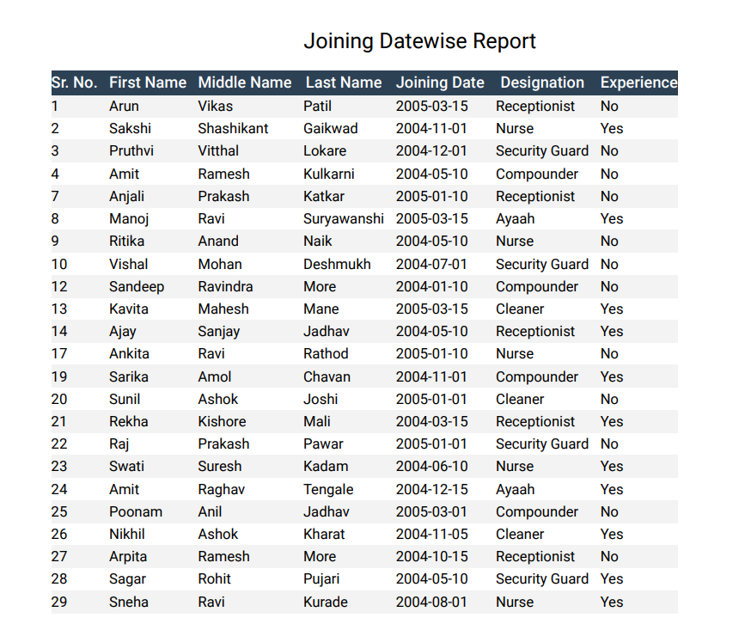

**6.6 Employee Bank Report :**

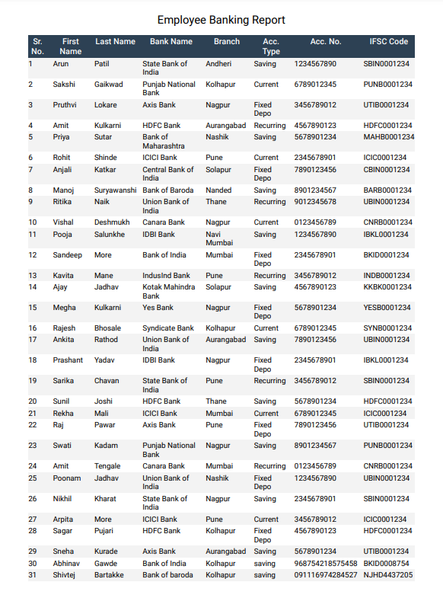

**6.7 Patient Information Report :**

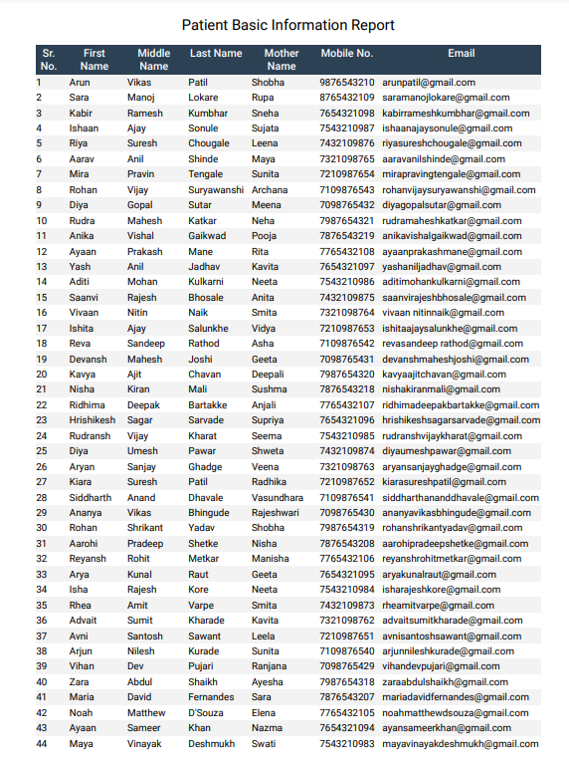

**6.8 Patient Details Report :**

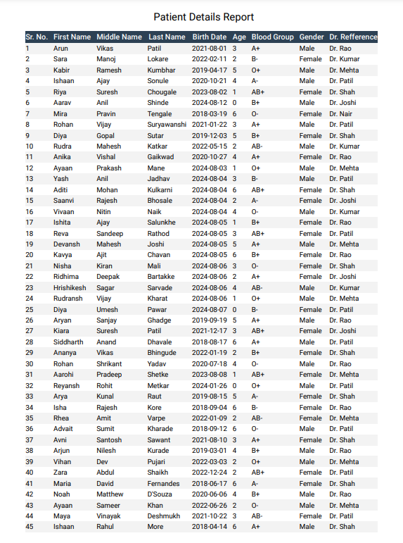

**6.9 Patient Birthdate-wise Report :**

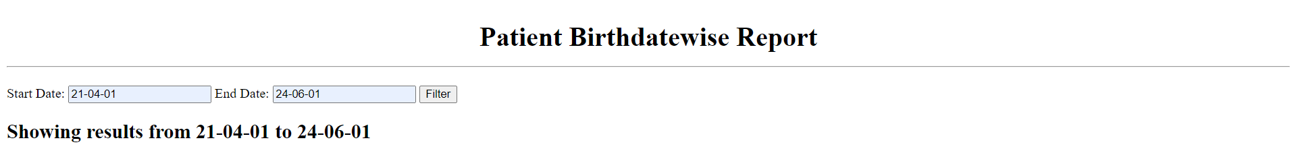

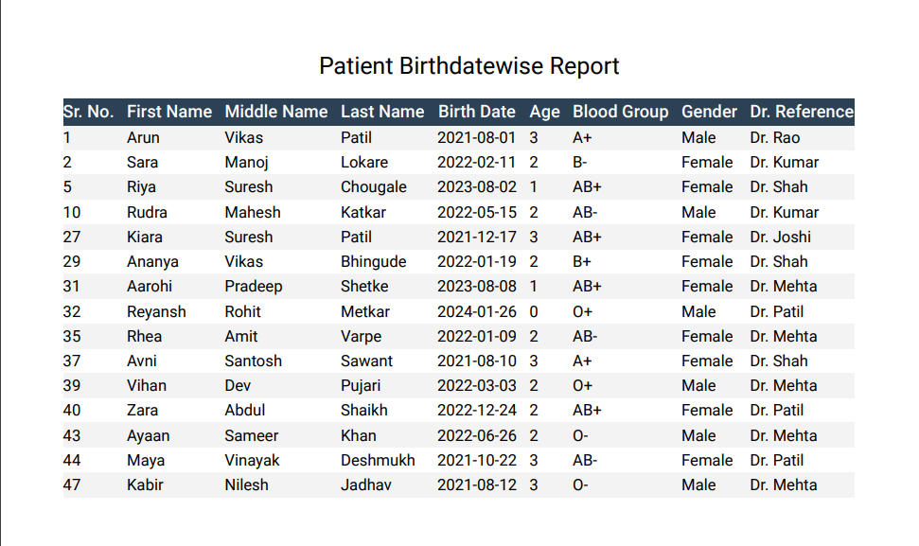

# CHAPTER-7

# CONCLUSION &

# SUGGESTION FROM

**PROJECT**

**7.1 Conclusion :**

Being a computerized system, it is accurate, time saving and beneficial with paperless documents. It minimizes error at greater extent. It gives you information about working of the various department. This “Pharmacy Distribution System” provide an integrated, user-friendly management system for both staff and admin, the port addresses many of the challenges present in traditional pharmacy management systems.

Additionally, the system’s use of modern web technologies such as HTML, CSS, JavaScript and PHP provides a solid foundation for future growth and scalability. It ensures, the system can maintain data security and system performance.

In conclusion, Adoption of “Pharmacy Distribution System“ boosts the productivity of the employee and gets the actual work done in proper and accurate manner. the system not only improves the efficiency of pharmacy distribution services but also enhances the experience for Admin and Staffs. The system's ability to automate and simplify various aspects of the pharmaceutical processes will lead to more accurate assessments, timely interventions, and better overall outcomes.

**7.2 Limitation :**

While the “Pharmacy Distribution System” provides many advantages in streamlining all processes in pharmacy management, there are certain limitations to the system that should be acknowledged:

* This System is not fully automated.
* Man power is required for handling this system
* Basic computer knowledge is compulsory for handling system
* This system required good network of Internet connection.

Despite these limitations, “Pharmacy Distribution System” provides a good performance and user friendly experience, addressing these limitations through further development and support could enhance its effectiveness and ensure that it meets the needs of a wider range of users.

**7.3 Suggestion :**

To further enhance the “Pharmacy Distribution System” and overcome its limitations, the following suggestions are proposed:

* Log out when system is not in use.
* Keep outside people away it may temper your data.
* Insert proper records in system.
* Records should not be blank while inserting data into system.
* Database maintenance is required.

By implementing these suggestions, the Audiologists Diagnostic Assessment Port can become a more comprehensive and adaptable tool, further enhancing the quality and improving the overall user experience for Admin and Staff.

# CHAPTER-8 ANNEXURE OF

**PROJECT**

**WEEKLY PROGRESS REPORT**

Weekly Progress Report No. 1

|  |  |
| --- | --- |
| Name of Student | Vishwajeet Anandrao Chavan |
| Title of the Project | Pharmacy Distribution System |
| Name of Guide | Mr. Shridhar B. Khot |
| Organization | COMTRANSE TECHNOLOGY PVT.LTD. |
| Date of Joining Organization | 27th May 2024 |
| Date of Progress Report | 27th May 2024 TO 2nd June 2024 |
| Period of Progress Report | 7 Days |
| Progress :   * Problem Identification. * Project Topic Finalization. * Submission of Synopsis. * Introduction to HTML, CSS, JavaScript, Python. | |

Signature of Student Signature of Industry Guide

**WEEKLY PROGRESS REPORT**

Weekly Progress Report No. 2

|  |  |
| --- | --- |
| Name of Student | Vishwajeet Anandrao Chavan |
| Title of the Project | Pharmacy Distribution System |
| Name of Guide | Mr. Shridhar B. Khot |
| Organization | COMTRANSE TECHNOLOGY PVT.LTD. |
| Date of Joining Organization | 27th May 2024 |
| Date of Progress Report | 3rd June 2024 TO 9th June 2024 |
| Period of Progress Report | 7 Days |
| Progress :   * Introduction to SQL. * Basic Commands in SQL. * Function of SQL. | |

Signature of Student Signature of Industry Guide

**WEEKLY PROGRESS REPORT**

Weekly Progress Report No. 3

|  |  |
| --- | --- |
| Name of Student | Vishwajeet Anandrao Chavan |
| Title of the Project | Pharmacy Distribution System |
| Name of Guide | Mr. Shridhar B. Khot |
| Organization | COMTRANSE TECHNOLOGY PVT LTD. |
| Date of Joining Organization | 27th May 2024 |
| Date of Progress Report | 10th June 2024 TO 16th June 2024 |
| Period of Progress Report | 7 Days |
| Progress :   * Introduction to Creating Database Table. * Installing Latest Version of XAMPP. * Overview of HTML, CSS, JavaScript. | |

Signature of Student Signature of Industry Guide

**WEEKLY PROGRESS REPORT**

Weekly Progress Report No. 4

|  |  |
| --- | --- |
| Name of Student | Vishwajeet Anandrao Chavan |
| Title of the Project | Pharmacy Distribution System |
| Name of Guide | Mr. Shridhar B. Khot |
| Organization | COMTRANSE TECHNOLOGY PVT LTD. |
| Date of Joining Organization | 27th May 2024 |
| Date of Progress Report | 17th June 2024 TO 23rd June 2024 |
| Period of Progress Report | 7 Days |
| Progress :   * SRS Submission and Approval. * Introduction to CodeIgniter. | |

Signature of Student Signature of Industry Guide

**WEEKLY PROGRESS REPORT**

Weekly Progress Report No. 5

|  |  |
| --- | --- |
| Name of Student | Vishwajeet Anandrao Chavan |
| Title of the Project | Pharmacy Distribution System |
| Name of Guide | Mr. Shridhar B. Khot |
| Organization | COMTRANSE TECHNOLOGY PVT.LTD. |
| Date of Joining Organization | 27th May 2024 |
| Date of Progress Report | 24th June 2024 TO 30th June 2024 |
| Period of Progress Report | 7 Days |
| Progress :   * Data Flow Diagram. * Entity Relationship Diagram. * UML Diagram. | |

Signature of Student Signature of Industry Guide

**WEEKLY PROGRESS REPORT**

Weekly Progress Report No. 6

|  |  |
| --- | --- |
| Name of Student | Vishwajeet Anandrao Chavan |
| Title of the Project | Pharmacy Distribution System |
| Name of Guide | Mr. Shridhar B. Khot |
| Organization | COMTRANSE TECHNOLOGY PVT.LTD. |
| Date of Joining Organization | 27th May 2024 |
| Date of Progress Report | 1st July 2024 TO 7th July 2024 |
| Period of Progress Report | 7 Days |
| Progress :   * Completed Database Design Using MySQL. * Completed Design. | |

Signature of Student Signature of Industry Guide

**WEEKLY PROGRESS REPORT**

Weekly Progress Report No. 7

|  |  |
| --- | --- |
| Name of Student | Vishwajeet Anandrao Chavan |
| Title of the Project | Pharmacy Distribution System |
| Name of Guide | Mr. Shridhar B. Khot |
| Organization | COMTRANSE TECHNOLOGY PVT.LTD. |
| Date of Joining Organization | 27th May 2024 |
| Date of Progress Report | 8th July 2024 TO 14th July 2024 |
| Period of Progress Report | 7 Days |
| Progress :  Admin Module -   * Connecting MySQL Database Using PHPCompleted. * Completed Front Office Module. * Reports Generated. | |

Signature of Student Signature of Industry Guide

**WEEKLY PROGRESS REPORT**

Weekly Progress Report No. 8

|  |  |
| --- | --- |
| Name of Student | Vishwajeet Anandrao Chavan |
| Title of the Project | Pharmacy Distribution System |
| Name of Guide | Mr. Shridhar B. Khot |
| Organization | COMTRANSE TECHNOLOGY PVT.LTD. |
| Date of Joining Organization | 27th May 2024 |
| Date of Progress Report | 15th July 2024 TO 21st July 2024 |
| Period of Progress Report | 7 Days |
| Progress :   * Reports Generated. * Complete Output Design | |

Signature of Student Signature of Industry Guide

**WEEKLY PROGRESS REPORT**

Weekly Progress Report No. 9

|  |  |
| --- | --- |
| Name of Student | Vishwajeet Anandrao Chavan |
| Title of the Project | Pharmacy Distribution System |
| Name of Guide | Mr. Shridhar B. Khot |
| Organization | COMTRANSE TECHNOLOGY PVT.LTD. |
| Date of Joining Organization | 27th May 2024 |
| Date of Progress Report | 22nd July 2024 TO 27th July 2024 |
| Period of Progress Report | 6 Days |
| Progress :   * Start Working on first draft. * Explained and Present project details to company. | |

Signature of Student Signature of Industry Guide

**GUIDE STUDENT MEETING RECORD**

**Student Name :**

**Guide Name :**

**Contact No. :**

**Topic :**

**Industry Name :**

**Industry Guide Name :**

**Designation :**

**Contact No. :**

|  |  |  |  |  |
| --- | --- | --- | --- | --- |
| **Sr.**  **No.** | **Date** | **Description** | **Signature of Institute Guide** | **Signature of Student** |
| 1 |  | Problem Identification, Topic Finalization, Submission of Synopsis.  (First week of In-plant training) |  |  |
| 2 |  | SRS submission and approval (Fourth week of In-plant training) |  |  |
| 3 |  | Logical Design of System (DFD, System flowchart, ERD, UML Diagrams, Decision tables, Design tree, etc. which is applicable)  (Fifth week of In-plant training) |  |  |
| 4 |  | Database Design  (Sixth week of In-plant training) |  |  |
| 5 |  | Input/Output Design  (Eight week of In-plant training) |  |  |
| 6 |  | Submission of First Draft  (Second week of Sem III) |  |  |
| 7 |  | Submission of Second Draft  (Fifth week of Sem III) |  |  |
| 8 |  | Submission of Final Draft  (Tenth week of Sem III) |  |  |

|  |  |  |  |  |
| --- | --- | --- | --- | --- |
| **Sr.**  **No.** | **Date** | **Description** | **Signature of Institute Guide** | **Signature of Student** |
| 1 |  |  |  |  |
| 2 |  |  |  |  |
| 3 |  |  |  |  |
| 4 |  |  |  |  |
| 5 |  |  |  |  |
| 6 |  |  |  |  |
| 7 |  |  |  |  |
| 8 |  |  |  |  |

# CHAPTER-9 REFERENCE

**FOR**

# PROJECT

### **References :**

During the development of our system, we have taken the reference from various books and websites, which we would like to mention in this section.

### **Reference Books :**

* + Robin Nixon - Learning My-SQL, JavaScript, CSS, HTML : O’Reilly Publication.
  + W Jason Gilmore - My-SQL: From Novice to Professional, Fourth Edition.
  + Jesus Caspagnetto – Professional PHP Programming Etal Wrox
  + Kogent Learning Solution - Web Technologies Black Book Dreamtech Press.
  + Ralph Mosely and M. T. Savaliya - Developing Web Application : Wiley India.

### **Websites :**

* [www.w3schools.com](http://www.w3schools.com)
* [www.javatpoint.com](http://www.javatpoint.com)
* [www.tutorialspoint.com](http://www.tutorialspoint.com)
* [www.getbootstrap.com](http://www.getbootstrap.com)
* [www.w3schools.com](http://www.w3schools.com) and [www.javatpoint.com](http://www.javatpoint.com) for JavaScript
* Bootstrap Reference Guide